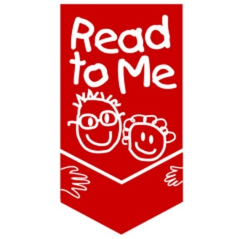
READ TO ME RENDEZVOUS
November 2 - 3, 2017
Boise, Idaho

Meeting Objective: To build the capacity of public and school library staff to ensure more Idaho children are reading on grade level by third grade.
Desired Outcomes:
Day 1 (Designed for Public Library Staff):
- Participants will increase their ability to serve homeschooled children in the public library setting
- Participants will increase their ability to facilitate storytimes for infants
- Participants will build capacity to serve diverse families in the library
- Participants will increase their knowledge of early literacy skills, and how to develop those skills through storytimes and library environment; OR Participants will learn why and how to evaluate library programs, and how to strengthen their ability to write and implement grants
Day 2 (Designed for Public Library Staff, School Library Staff, School Staff):
- Participants will begin or strengthen partnerships that advance literacy in their communities.
- Participants will understand how adverse childhood experiences impact school readiness
- Participants will learn how early STEM activities can support the development of literacy skills
AGENDA
Thursday, November 2, 9:00 a.m. – 5:30 p.m.
9:00 - 9:30 Registration opens & light breakfast
9:30 – 12:00
Welcome and introductions
Serving Homeschoolers at the Library: Travis Porter, Meridian Library District, Silverstone Branch
Lapsit programs: Facilitating library storytimes for families with infants: Julie Patricia, Ada Community Library, Lake Hazel Branch
12:00 - 1:00 Lunch & Panel Discussion: Serving diverse patrons
1:00 - 4:00 Breakout Sessions:
Option 1 – Introduction to Early Literacy Skills (geared toward new library staff): Staci Shaw and Tammy Hawley- House, Idaho Commission for Libraries
Option 2 – Program Evaluation, Outcomes-Based Measurement, & Grant Writing Tips: Megan Egbert, Meridian Library District; Patrick Bodily, Idaho Commission for Libraries; Kristina Taylor, Idaho Commission for Libraries
4:15 - 5:00
Networking and Action Planning
5:00 - 5:30
Join us for Read to Me’s 20th Anniversary Celebration!
(Dinner on your own – meal reimbursed if you traveled more than 40 miles away)
Friday, November 3, 8:30 a.m. – 3:30 p.m. (School Librarians & Public Librarians)
8:00 - 8:30 Registration for new attendees and Breakfast
8:30 Opening comments
9:00 – 12:00
The Brain Game: How early childhood experiences affect school readiness: Roger Sherman, Idaho Children’s Trust Fund; Jane Zink, Idaho Association for the Education of Young Children
School and Library Partnerships: Models that support beginning readers: Various libraries
12:00 – 1:00 Working lunch & featured speakers
1:00 – 3:30
STEM and Beginning Readers: How math and science activities support the development of literacy: Sesha Hammond
3:30 Adjourn

