**Fairytale Bulletin Board Ideas**

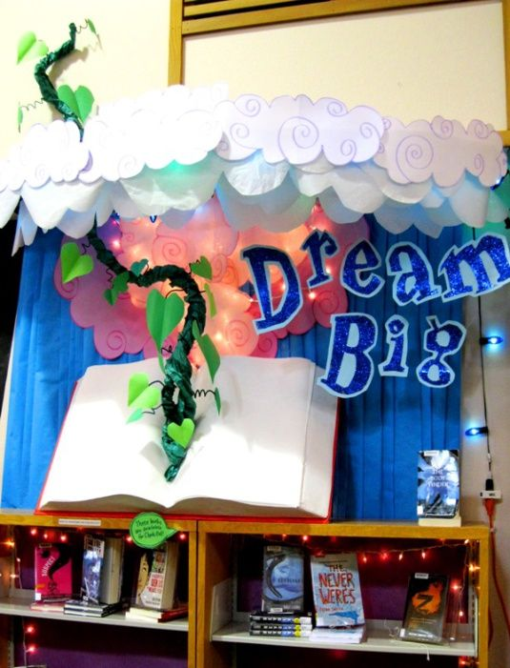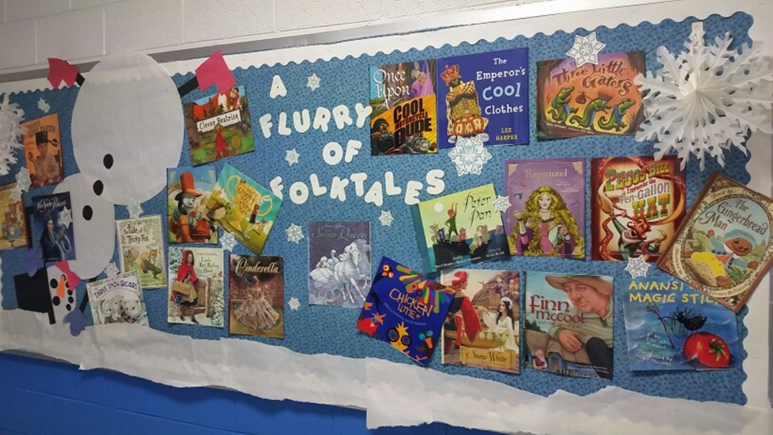

**“Mrs. Curry’s K” -** <http://mrscurryteacher.blogspot.com/2014/08/its-fairy-tale-year.html>

