Fairytale Storytime – All About Castles and Dragons!
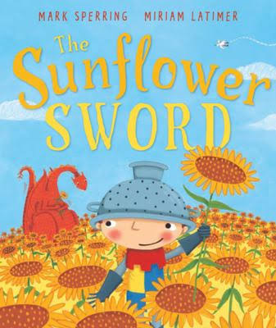
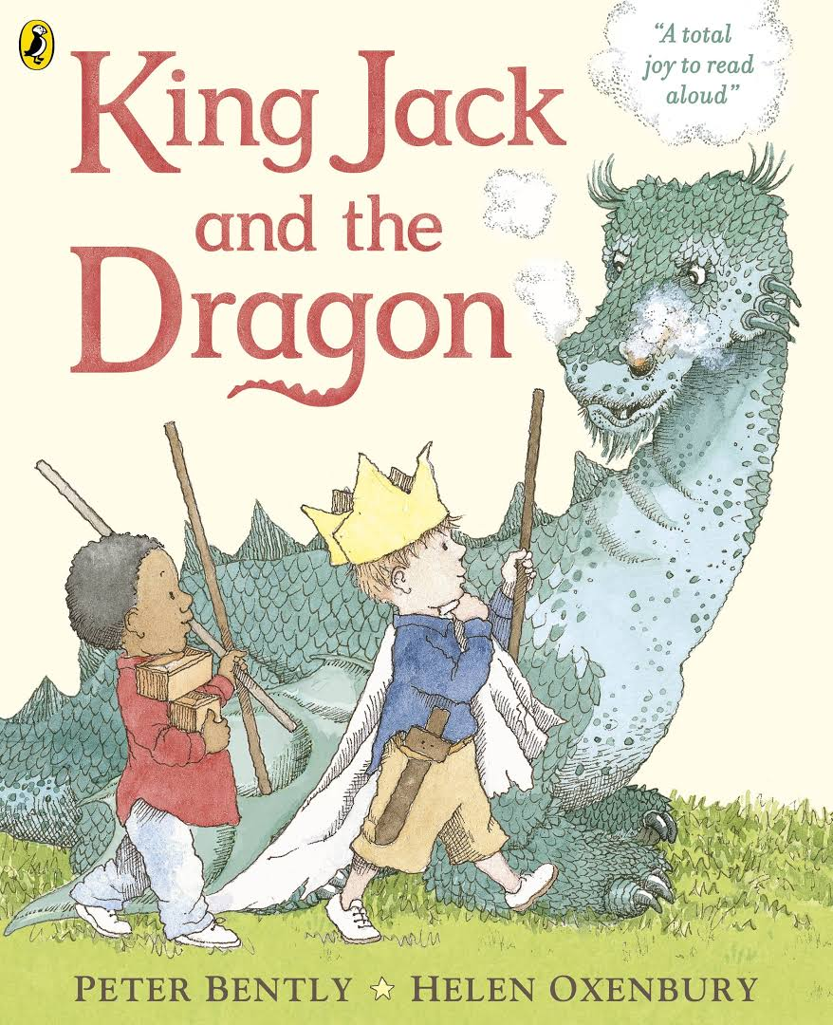
Books:

The Sunflower Sword by Mark Sperring and Miriam Latimer
Over at the Castle by Boni Ashburn
King Jack and the Dragon by Peter Bently and Helen Oxenbury
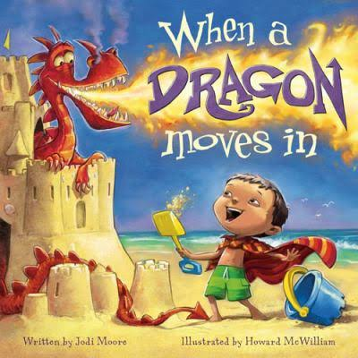
The Foggy Foggy Forest by Nick Sharratt
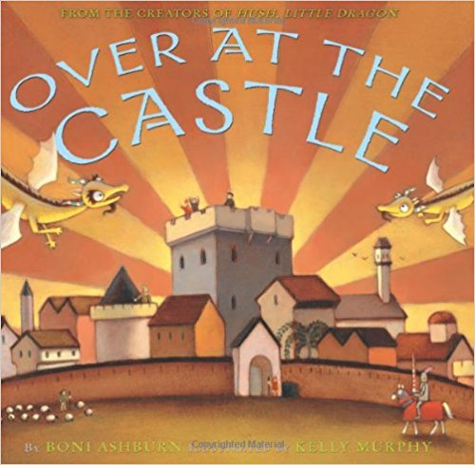
When a Dragon Moves In by Jodi Moore
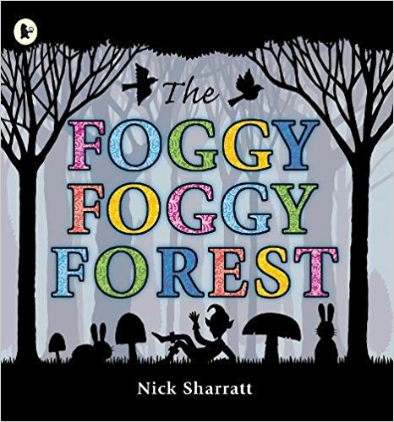
Max’s Dragon by Kate Banks
Max’s Castle by Kate Banks

Flannelboard Story:

https://storytimekatie.com/2011/12/16/flannel-friday-knights/
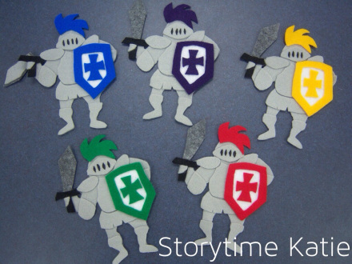
Five Knights in Shining Armor
Five knights in shining armor,
Fearless and brave,
Went dragon hunting deep in a cave.
The dragon started breathing fire,
The knights’ knees were all aquiver,
So one little knight went off for the river!
(repeat counting down to zero)
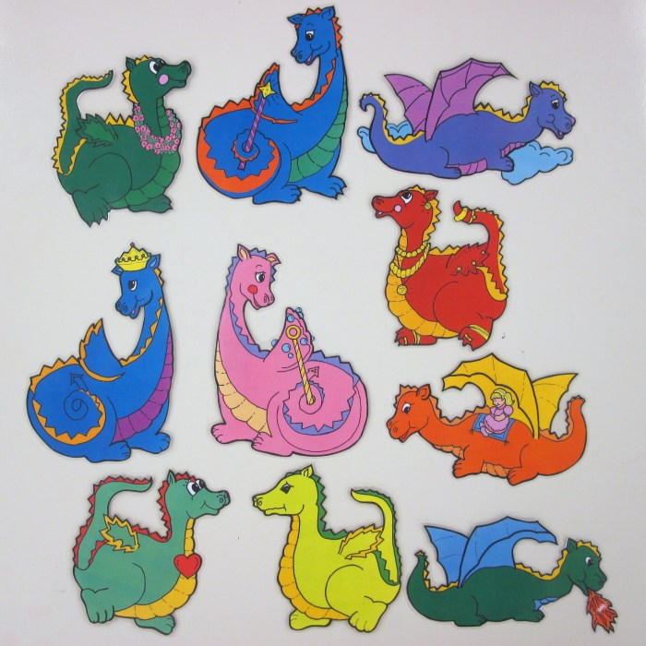

Also, check out: https://sunflowerstorytime.com/2011/06/24/once-upon-a-time/ for a “Ten Dizzy Dragons” Flannel Rhyme

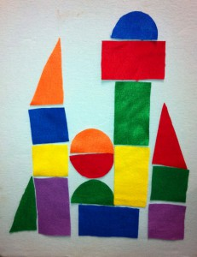
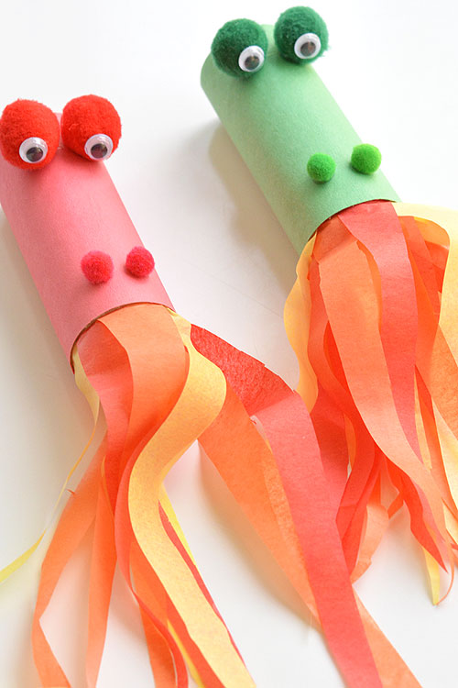

Extension Activities:

Fire-Breathing Dragon: http://laughingkidslearn.com/make-fire-breathing-dragon-using-cardboard-toilet-roll/

Build a Castle with Shapes: http://melissa.depperfamily.net/blog/?p=2857

Dragon Mask: http://www.woojr.com/chinese-new-year-printable-craft-dragon-animal-masks/printable-dragon-mask/

Songs and Fingerplays:

Little Dragon
Little dragon counts to three. Little dragon bends one knee.
Little dragon whistles and sings. Little dragon flaps his wings.
Little dragon touches his toes, Little dragon scratches his nose.
Little dragon makes a funny face, Little dragon runs in place.
Little dragon lays on the floor. Little dragon starts to snore.
I’m a Little Dragon
(Tune: "I’m a Little Teapot" )
I’m a little dragon, strong and stout.
Here is my tail and here is my snout.
If you get me upset, you better watch out!
I’ll give you something to shout about!
From: https://www.jocolibrary.org/kids/storytime-blog/dragons-preschool-storytime

Dragon Hunt

Going on a dragon hunt. [slap thighs]
And I'm not afraid. [point to self]
There's a tall mountain. [Look with hand over eyes]
Can't go under it. [move hand down]
Can't go around it. [move hand around]
Guess I'll go over it. [reach hands as if climbing]
There's a river. Can't go over it. Can't go around it.
Guess I'll swim across it. [move arms as if swimming]
There's some tall grass.
Can't go over it. Can't go around it. Guess I'll go through it. [slap hands up and down in front]
There's a castle! Can't go over it, can't go under it. Guess I'll go in it.
It's dark and spooky in here [shake] It's cold in here! [wrap arms around self and shiver]
I feel some scales. [pretend to rub something]
I feel some teeth. [pretend to touch something]
OH! It's a dragon! [scream] Run out of the castle. [slap thighs]
Go through the grass, swim across the river, climb over the mountain, run home. [slap thighs]
Open the door, jump into bed [cover head with arms to hide]
I went on a dragon hunt, and I wasn't afraid.

