# **Fairytale Storytime – All About Fractured Tales!**

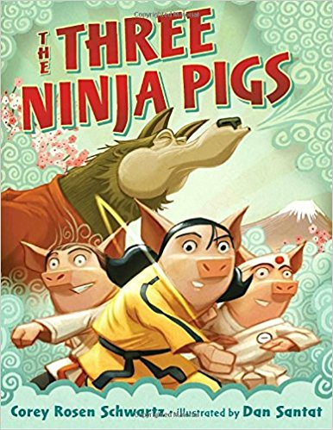

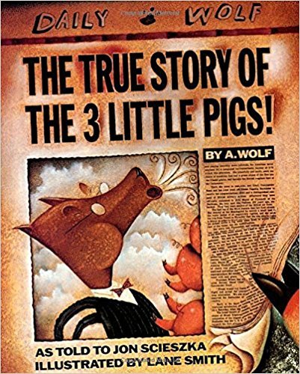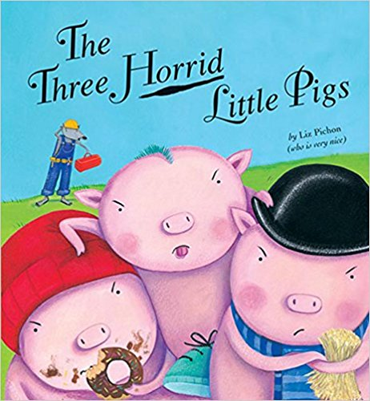**Books:**

“Three Little Pigs” retellings:

* *The Three Horrid Little Pigs*   
  by Liz Pichon
* *The Three Ninja Pigs*   
  by Corey Rosen Schwartz
* *The True Story of the 3 Little Pigs* by Jon Scieszka

*
                            LITTLE ROJA RIDING HOOD by Susan Middleton Elya*

**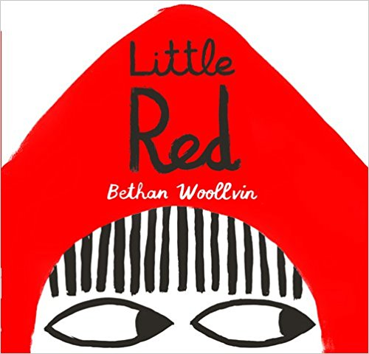***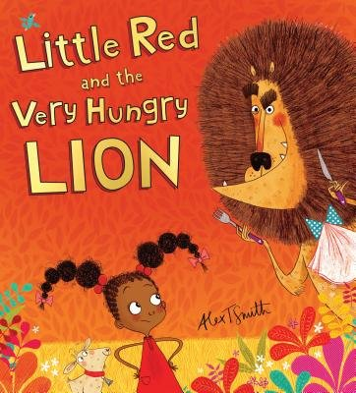*

“Little Red Riding Hood” retellings:

* *Little Red* by Bethan Woollvin
* *Little Roja Riding Hood*   
  by Susan Middleton Elya
* *Little Red and the Very Hungry Lion*   
  by Alex T. Smith

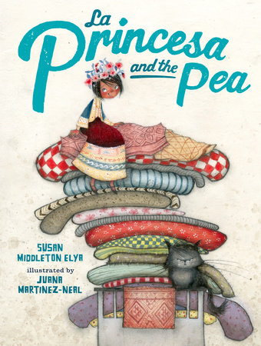

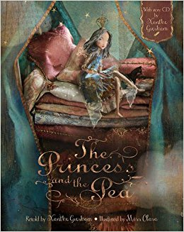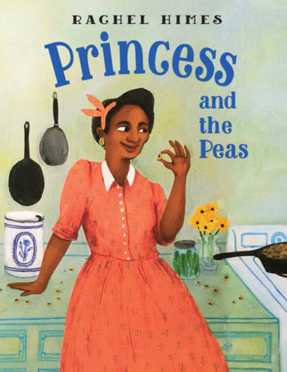

“Princess and the Pea” retellings:

* *Princess and the Pea*   
  by Xanthe Gresham
* *La Princesa and the Pea*   
  by Susan Middleton Elya
* *Princess and the Peas*   
  by Rachel Himes

**More multicultural stories:** <http://www.readbrightly.com/multicultural-fairy-tales-for-children/>

**Flannelboard Story:**

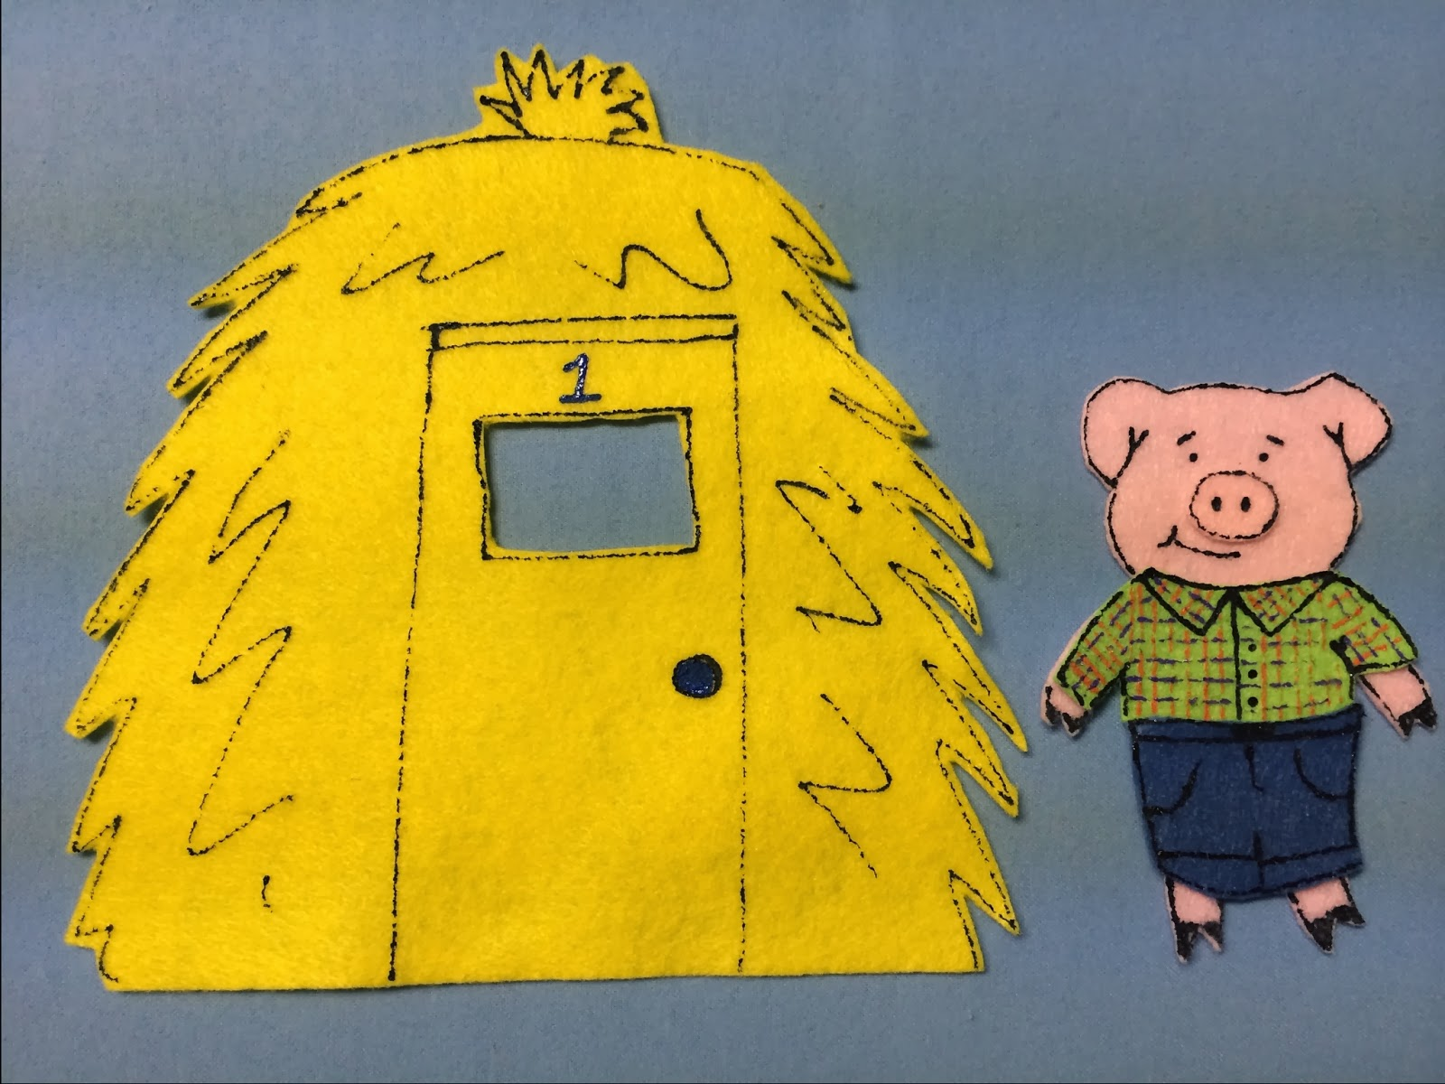**“Three Little Pigs” Flannel:**

<http://libraryvillage.blogspot.com/2014/03/flannel-friday-three-little-pigs.html>

**Extension Activities:**

* 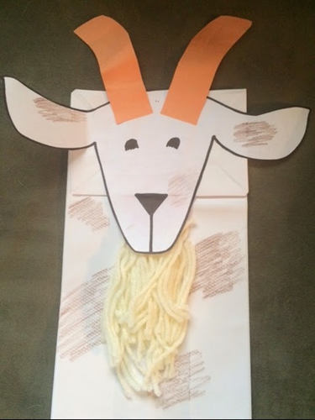**Make a Billy Goat Puppet using:** a white bag, goat head cut outs, snipped yarn, and markers

**Write your own fairy tale:**

**Check out the *Fairytale Story Map Outline* in the “Activities” section of our FRW website at:** <http://libraries.idaho.gov/landing/idaho-family-reading-week>

“How to Write a Newfangled Fairy Tale” article: <http://www.fictionteachers.com/fictionclass/newfangled.html>

* **Incorporate a STEM Activity:** <http://www.alsc.ala.org/blog/2012/10/the-three-little-pigs-the-preschool-science/>

**Fingerplay:**

*This Little Piggy*

Make this traditional rhyme interactive by having the children suggest new destinations and foods for the piggies. Write their suggestions on a board or flipchart, then have everyone recite the new rhymes together. Example:

“This little piggy went to the zoo,

This little piggy stayed home.

This little piggy had ice cream,

And this little piggy had none.

And this little piggy went “Wee! Wee! Wee!” all the way home.”