This FREE early literacy workshop focuses on the importance of reading to children, laying a foundation for getting children ready to read, and how to use free resources found in the local library. The curriculum is built upon the Six Early Literacy Skills recommended by the National Research Council. Each skill will be explored through a variety of fun activities and practical examples. The skills developed are appropriate for use with children ages 2 years through kindergarten.

A free Literacy Kit containing books and materials will be provided for each classroom, in order to build on-site libraries and support the teaching of early literacy skills.

Three IdahoSTARS credits are available at no cost for participants who wish to submit an IdahoSTARS Evaluation after the workshop. The workshop is three hours, with a short break.

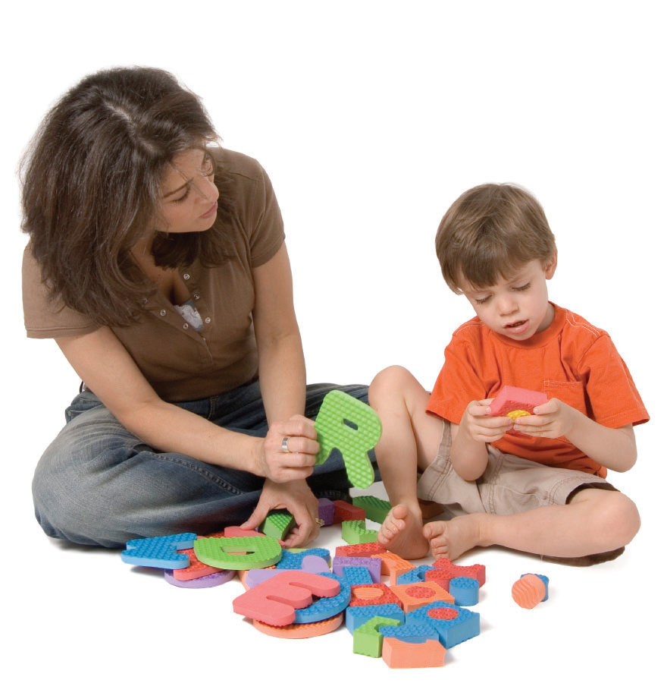
Workshop date:
Time:
Location:

Directions:

Registration Information:

Contact person:

Seats are limited. Please register early!

