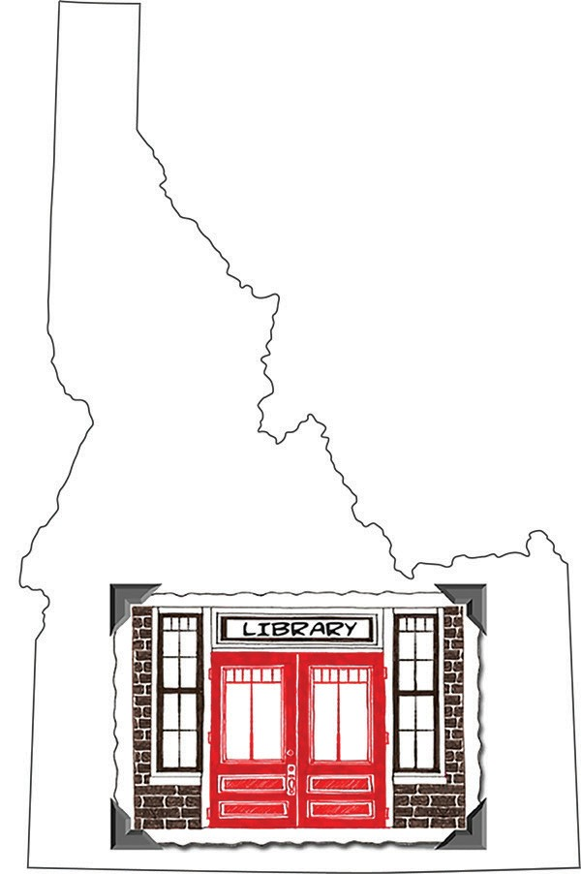Today is Idaho Library Snapshot Day!

Snapshot Day

We will be taking photographs of people using the library today.

If you do NOT wish to be photographed, please tell the person taking the picture, and they will not photograph you.

We would appreciate you taking a moment to fill out a survey to let us know how you use the library. Or email comments to:
name@emailaddress.

Thank you for helping us capture a typical day in our Idaho library!

