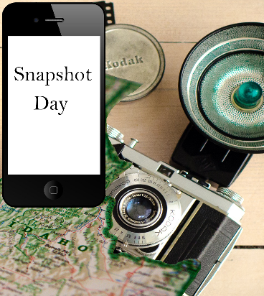
Package the Idaho Library Snapshot Day data and use it to showcase the value of Idaho libraries.
Brag about your results!
Some easy ways to create Snapshot success for your library.
Use the quotes and comments that you collected in your annual report, social media, emails, and other outreach.

Feature your participation in your next newsletter.

Share your results with your board, friends group, community leaders, etc.

Make bold signs with your patrons’ comments and display them throughout the library.

Develop a page for your website -- and ask if you can post it to your town’s website, too.

Create a slideshow of your photos to be shown at your library -- and perhaps your local cable and/or PBS TV station would air them and/or add them to their websites.

Submit a press release and/or a photo/caption to your local newspaper. (If you have the contact information for the patron in the photo, and permission to give it, share that with the reporter, so they are able to contact the patron for an interview.)

