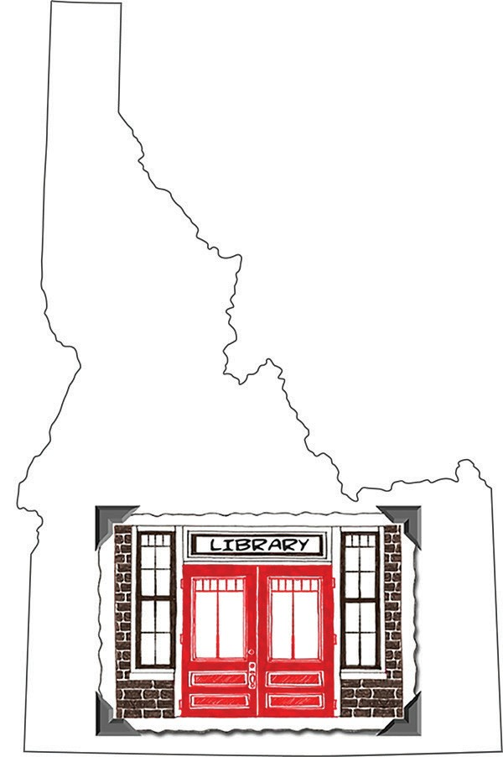Idaho Library Snapshot Day 2017 --- Printable Survey

Snapshot Day

Please enter the contact information for your library.

Your name: Library or School: City / Town: Email Address or Phone Number:

Type of Library (public, school, academic, special/other):
Capture a typical day in your Idaho library on Snapshot Day.

- When did your library hold its Snapshot Day?

- Please provide the following Snapshot Day statistics. Feel free to estimate, when necessary, and skip anything that doesn’t apply to your library.
How many people visited the library: OR How many classes visited the library: What was the total circulation for the day: How many reference questions were answered (either in the library or classroom): How many unique searches were performed in research databases: How many job seekers were helped (résumé, job search, etc.): How many students were helped with homework:
How many people used public access computers (in public libraries) or student computers (in school/academic libraries) for Internet/word processing/ games, etc.:
How many people accessed the Internet with their own devices: How many volunteer/community service hours: How many people were taught computer/device/Internet skills: How many library cards were issued or borrowers registered:

Optional. Include other significant statistics for your library or clarification of statistics in question #4, if needed:

- Tell us about any programs and activities that apply to your library.

Please estimate how many people attended your programs: Please estimate how many people attended your library tour(s): Please estimate how many people attended outreach events: Please estimate how many people attended classes (technology, tutoring, etc.): Please estimate how many community members used meeting rooms:

Optional. Include other significant program information for your library and/or clarification of question #6:

- Optional. Share examples of reference questions:

- Share quotes/comments from your library users:

- Tell us how your library plans to use your results from Idaho Snapshot Day. (Check all that apply.)

Link to results from your website.

Share results in a thank you letter to your friends group, board, local officials, PTA, administrators, etc. Share results or use quotes from your library users in your newsletters, social media, press releases, etc. Create a promotional poster, bookmark, and/or postcard with quotes/photos.
Display a slideshow of quotes/photos in your library. Other. (Please share your great ideas.)

Anything else you would like to add -- unique program, comments about Snapshot Day, etc.

Please enter this survey information online at: www.surveymonkey.com/s/IdahoSnapshot2017 by Friday, April 28, 2017.
You may also email some of your Snapshot Day photos (that you have permission to use) to Donna Eggers at: donna.eggers@libraries.idaho.gov. File size should be between 1 MB and 3 MB.
Please participate in Snapshot Day and help us tell the story of Idaho’s libraries.

