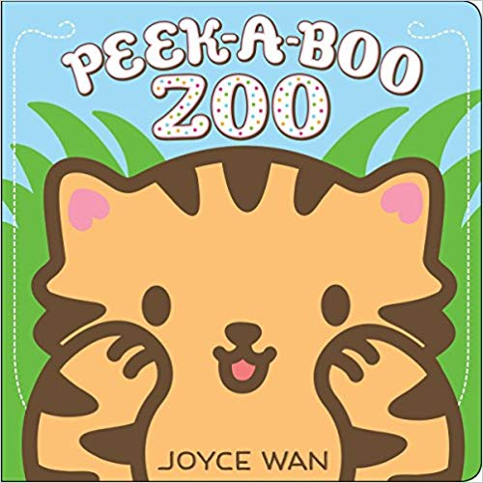
Babies Storytime – Peek-a-Boo!

Books:
“Peek-a-boo Zoo” by Jane Cabrera
“Peekaboo Morning” by Rachel Isadora
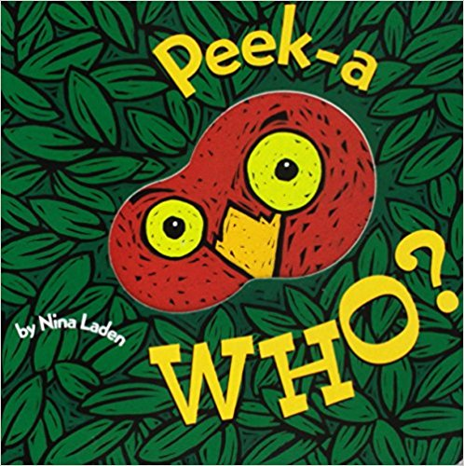
“Where Is Baby’s Bellybutton?” by Karen Katz
“Begin Smart Peek-a-Boo What?” by Elliot Kreloff
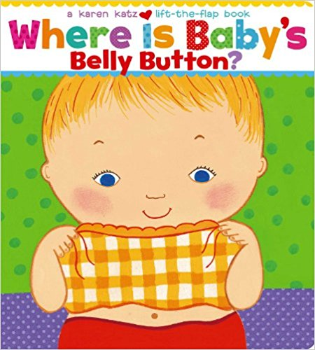
“Peek-a-Who” by Nina Laden
“Goodnight Faces” by Lucy Schultz and Ana Larranaga
“Baby Says Peekaboo!” by Dawn Sirett (DK Books)
“Spots, Feathers & Curly Tails” by Nancy Tafuri

Early Literacy Tip: Playing peek-a-boo and reading lift-the-flap books with babies helps them develop object permanence, which is the ability to know that something exists even when baby can’t see it. Eventually, infants begin to form mental representations of objects they cannot see, which can help with separation anxiety. This type of symbolic thinking is also an important first step in developing early reading skills.

Songs and Fingerplays:
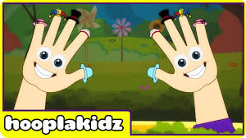
Where Is Thumbkin (Source: Hoopla Kids Official Storytime Channel)

Songs and Fingerplays (cont.):
Song (with scarves): Where Is Baby? (Tune: “Where Is Thumbkin?”)
Where is baby? Where is baby? (cover baby’s face)
There she is. There she is. (peek under scarf)
I’m so glad to see you. I’m so glad to see you.
Peek-a-boo! I see you! (kiss)
(Credit: Public Library of Charlotte and Mecklenburg County)

Big A, Little A, Bouncing B (Source: Jbrary)

Flannel Boards:
Five Little Ducks (Source: Storytime Katie)
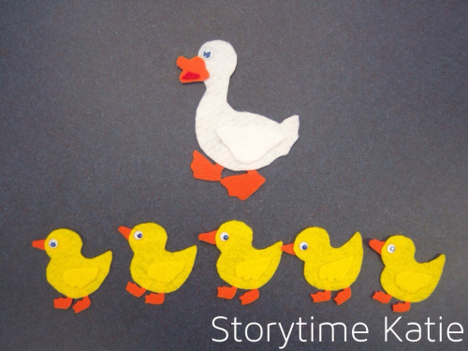
Five little ducks went out to play, over the hill and far away
Mother duck said, “Quack, quack, quack, quack”
And only four little ducks came back
(count down until)
Sad mother duck went out one day, over the hill and far away
Mother duck said, “Quack, quack, quack, quack”
And all of her five little ducks came back!

Two Little Blackbirds (Source: Jbrary)
Two little bluebirds sitting on a hill
One named Jack and one named Jill
Fly away Jack, fly away Jill
Come back Jack, come back Jill

Activities:
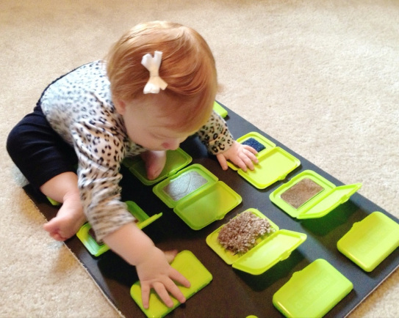
Peek-a-Boo Sensory Board (Source: Motherhood and Other Adventures)
Use leftover baby wipes lids, Altoid mint canisters, or any other flat containers with a lid, and fill them with objects that have different textures – soft, rough, smooth, etc. Then attach the containers to a foam-core poster board and let babies explore and practice opening and closing the lids – peek-a-boo, what’s inside?

