Preschool Storytime – Find It!

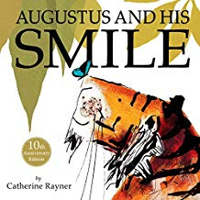
Books:
“Here a Face, There a Face” by Arlene Alda
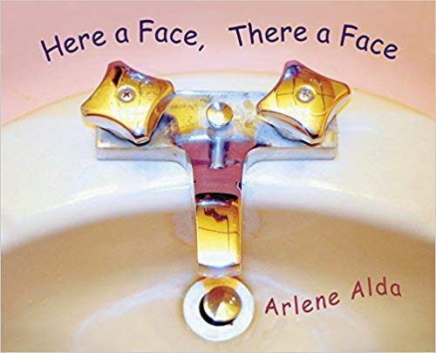
“Who Has this Tail?” by Laura Hulbert
“I Want My Hat Back” by Jon Klassen
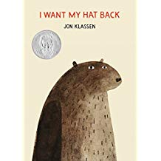
“I Spy” books by Jean Marzollo and Walter Wick
“Closer Look” by Mary McCarthy
“Augustus and His Smile” by Catherine Rayner
“Looking for a Moose” by Phyllis Root
“We’re Going on a Bear Hunt” by Michael Rosen
Early Literacy Tip: Reading books together exposes your child to new words. Learning new words gives children a strong foundation for learning to read when they are ready. As you read, have your child help find new words for you to explain.

Songs and Fingerplays:
Going on a Bear Hunt – this version from The Kiboomers is fun
Where Is Thumbkin?
Going on a Book Hunt (Source: Storytime Hooligans)
We’re going on a book hunt
We’re gonna find a big one!
Where can we go?
The library.

Oh look! A car!
A zoomy, vroomy car!
We can’t go over it,
We can’t go under it,
We can drive it!
Zoom, Vroom, Zoom, Vroom!

Oh look! The library steps!
We can’t go over them,
We can’t go under them,
We have to go up them!
Pitter patter pitter patter.

Oh look! A door!
A heavy, closed door!
We can’t go over it,
We can’t go under it,
We’ve gotta go through it!
Push, shove, push, shove.

Oh look! A checkout desk!
We can’t go over it,
We can’t go under it,
We have to go past it.
Beep beep beep beep.

Oh look! The library!
We can’t go over it,
We can’t go under it,
We’ve gotta go through it!
Walk walk walk walk.

Oh look! The books!
We can’t go over them,
We can’t go under them,
We’ve gotta go through them.
Pick, flip, pick, flip.
FOUND A GREAT ONE!

Now quick! Past the checkout desk, beep, beep, beep,
Through the library, walk, walk, walk,
Down the steps, patter patter,
Into the car, zoom, zoom
Run to the house, run up the stairs,
Oh oh forgot to shut the door!
Run back downstairs, shut the door,
Run back up, to the bedroom,
Jump into bed, pull up the covers,

AH! TIME FOR A STORY!

Activities:
I Spy Variations
Make the traditional I Spy game work for preschoolers by focusing on shapes (something round), letters (something that starts with the letter D or something that ends with the letter S), sounds (something that stars with the “sh” sound), numbers (three of something), etc.

Mystery Box
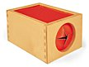
Place several items in a closed box with a hole just big enough for a child’s hand. Have the kids put their hand inside the box and try to describe the first item they grab without seeing it. Write down the descriptive words on sheet of paper or white board to encourage print awareness.

