Toddler Storytime – Look and Find

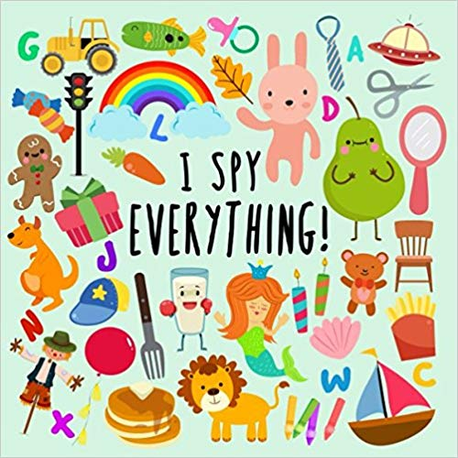
Books:
“I Spy Everything!” by Books for Little Ones
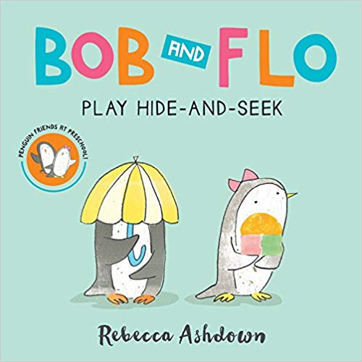
“Bob and Flo Play Hide-and-Seek” by Rebecca Ashdown
“I Lost My Dad” by Taro Gomi
“Whose Nose Is This?” by Peg Hall and Ken Landmark
“Who Took the Cookie from the Cookie Jar?” by Bonnie Lass and Philemon Sturges
“Where’s Walrus?” by Stephen Savage
“Peek in My Pocket” by Sarah Weeks
“I Went Walking” by Sue Williams
Early Literacy Tip: Research shows that hearing a question and forming a response engages three different parts of the brain, so it can take children a bit longer to respond to questions in look-and-find books. When you read look-and-find books with children, you encourage brain development, which can help with reading comprehension later on.

Songs, Rhymes, and Fingerplays:
Riding in My Stroller (Source: Storytime Source Page)
I’m riding in my stroller.
What do I see?
Two friendly people waving at me! (wave)

I’m riding in my stroller.
What do I hear?
Trucks and cars honking right in my ear! (honk)

I’m riding in my stroller.
Who trots past?
A big, happy dog who is going so fast. (bark)

I’m riding in my stroller.
What do I do?
Kick, kick, kick, there goes my shoe. (kick)

I’m riding in my stroller,
Sleepy as can be.
Now my eyes are closing – it’s nap time for me! (close eyes)

Who Stole the Cookies?
Who stole the cookies from the cookie jar?
(Say child’s name) stole the cookies from the cookie jar!
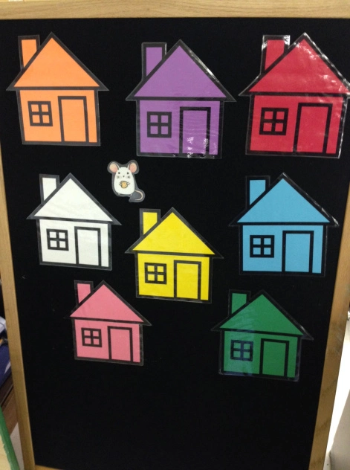
Who me? Yes, you!
Couldn’t be! Then who?
(repeat with other children’s names)

Flannel Boards:
Little Mouse, Little Mouse & Other Renditions (Source: Jbrary)
Brown Bear, Brown Bear, What Do You See by Bill Martin (Source for flannel pieces: Make Learning Fun)

Activities:
I Spy Game
Select and object in the room and say, “I spy with my little eye something that is (color)” and have the children guess what the object is. You can substitute other descriptive phrases for the color of the object (i.e. starts with the letter A, something squishy, something flat, etc.)

Hide-and-Seek (Hotter, Colder version)
Have someone leave the room while one (or more) person hides. When the first person comes back in, they try to find the person who is hiding and everyone else can help by calling out “hotter” or “colder” as the seeker gets near the hider.

