Fairytale Storytime – All About Princes and Princesses!
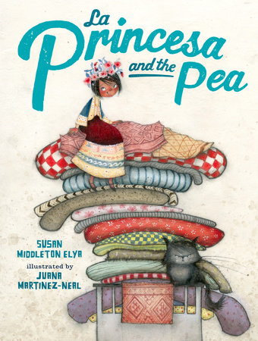
Books:
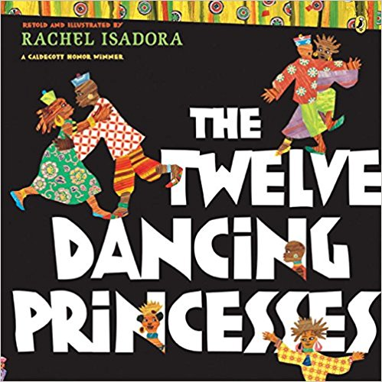
La Princesa and the Pea by Susan Middleton Elya
Not All Princesses Dress in Pink by Jane Yolen
The Twelve Dancing Princesses by Rachel Isadora
Falling for Rapunzel by Leah Wilcox
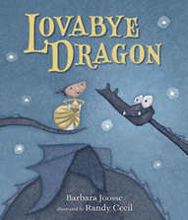
King Jack and the Dragon by Peter Bently
Lovabye Dragon by Barbara Joosse

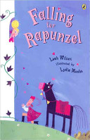
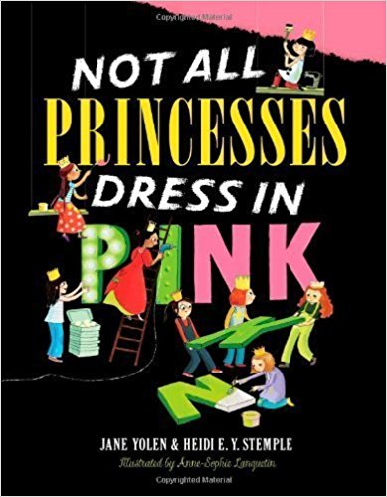
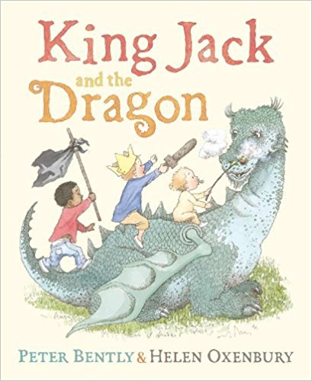
The Paperbag Princess by Robert MunschThe

Part-time Princess by Deborah Underwood

Princess Justina Albertina
by Ellen Dee Davidson

**Be sure to check out this list of multicultural retellings of some classic fairytales: http://www.readbrightly.com/multicultural-fairy-tales-for-children/

Storytime Prop:
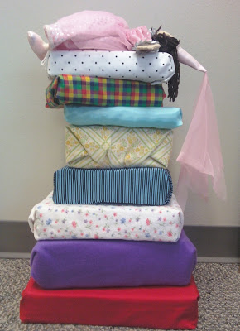
Princess and the Pea prop idea -

http://readsarahread.blogspot.com/2012/03/flannel-friday-princess-and-pea.html
Need more Flannelboard ideas? Consider participating in
Flannel Friday, an online event in which participating bloggers post a description of a flannelboard, puppet, or prop storytime activity on their blogs every Friday. All the participating posts are gathered into one spot in a link round-up. http://flannelfridaystorytime.blogspot.com/

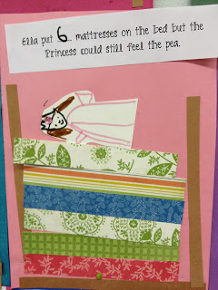
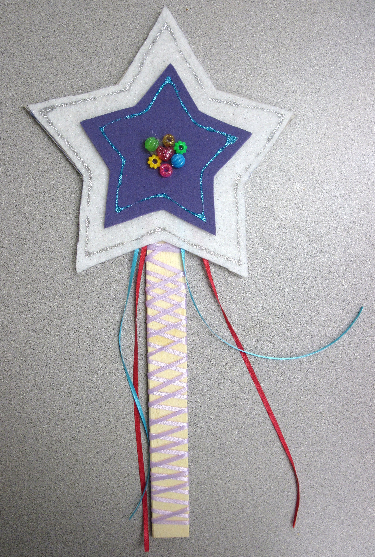
Extension Activities:

Magic Wand Wiggler: https://sunflowerstorytime.com/2011/06/24/once-upon-a-time/

Paper Plate Crown: http://www.busybeekidscrafts.com/Paper-Plate-Crown.html

Build Your Own Princess and the Pea bed:
http://mrsgoffskinders.blogspot.com/2012/03/fairy-tales-princess-and-pea.html

Write Your Own Fairytale:
Check out the Fairytale Story Map Outline in the “Activities” section of our FRW website at: http://libraries.idaho.gov/landing/idaho-family-reading-week

Fingerplays, Rhymes & Songs:

I’m a Little Princess
(to the tune of I’m a Little Teapot)
I’m a Little Princess
See my shiny crown
Here are my slippers
And here is my gown
If the dragon finds me, I won’t cry,
I will tickle him silly and wave goodbye.

https://kcls.org/content/im-a-little-princess/
Bow Like a Prince
(to tune of Skip to My Lou)
Bow like a prince just like so
Bow like a prince just like so
Bow like a prince just like so
Bow like a prince!
(Curtsy like a princess, juggle like a jester, fly like a fairy, roar like a dragon)

https://storytimehooligans.wordpress.com/2015/02/12/princess-storytime/

Here Is… from https://storytimekatie.com/2012/01/02/fairy-tales/

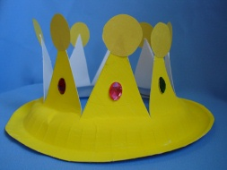
Here is the knight with his feathered cap (take off hat, bow)
Here are his boots which go tap, tap, tap (tap feet)
Here is the dragon, listen to him roar (roar)
Here are his wings to help him soar (soar)
Here is the princess with her golden crown (four fingers overhead)
Here is her lovely blue ball gown (curtsy)

