Summer Summit 2016
Presenters and Facilitators
(In order of appearance)
Tiffany Whitehead, aka the Mighty Little Librarian, is an obsessive reader, social media user, and technology geek. She is the school librarian at Central Middle in Baton Rouge, Louisiana. Tiff earned her undergraduate degree in Elementary Education and School Library Certification from Southeastern Louisiana University and her graduate degree in Educational Technology Leadership from Northwestern State University. She has served as the President for ISTE’s Librarians Network and was recognized as one of ISTE’s 2014 Emerging Leaders. Tiffany is National Board Certified in Library Media and was named one of the 2014 Library Journal Movers & Shakers. You can follow Tiff on Twitter @librarian_tiff.,
Dr. Rick Stoddart is an associate professor and Education librarian at the University of Idaho. He focuses his efforts on how the library meets the learning mission of the university through its instruction, reference, and public service programs. His research is focused on how library services, collections, and outreach can best enhance learning and community interaction. Rick is the chair of the ILA Information Literacy Committee and will be presenting his research at the European Conference on Information Literacy in October. His is a big fan of all the hard work school librarians do.

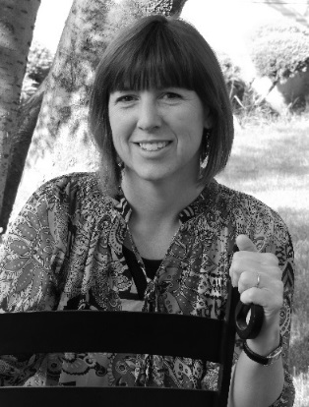
Lynn Johnson, M.E.T., is a school district library media specialist for a geographically large rural school district in North Central Idaho. She works with three other building librarians and is responsible for the administration of five libraries. She is also the building librarian for the Grangeville Elementary/Middle School Library. Lynn serves as the facilitator for the district improvement team, is on the ICfL LiLI steering committee, and works with the VALNet consortium library directors as the Bibliographic Standards representative. She holds a BS in Elementary Education from the University of Idaho, received her Library Media Endorsement through the University of Montana and the University of Montana Western and obtained her Masters of Educational Technology from Boise State University in 2014. This fall will be her eighth year as a School District Library Media Specialist. At home, she is a busy mother of teenage twin girls and, with her husband, attempts to keep up with their activities. They enjoy the outdoors, sports and our pets and livestock. They are active in 4H and Lynn volunteers as a leader for a variety of projects.

Kiersten Kerr is the Library Media Specialist at Coeur d'Alene High School. She also has elementary experience from her time as the Library Manager at Hayden Meadows Elementary School before her move to CHS. She earned her bachelor's degree from UCSD, and has just finished her MLIS. In addition to her duties in the library, Kiersten coaches the Coeur d’Alene High School State Champion (4th year in a row!) Skeet and Trap Team.

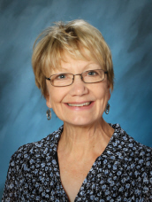
Becky Proctor is the Teacher-Librarian at West Jr. High at Boise’s West Jr. High School and Past President of the Idaho Library Association. She spent seven fun years as librarian at Jefferson Elementary School, served high school students in summer and evening school libraries in Boise, and worked three summers with Garden City Library’s bookmobile. Becky holds degrees in education from both the University of Oregon and Boise State University. She and her husband have two grown daughters.

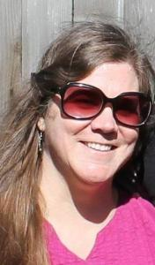
Tammy Hawley-House, after working in public libraries for over 20 years, is new’ish to the Idaho Commission for Libraries as a Read to Me Project Coordinator. She has a Master of Library Science and over 17 years’ experience as a children’s librarian working with early literacy programs. Before libraries she worked in accounting and has an under graduate degree in education. Other parts of her life include cooking, biking, traveling, dreaming of travel, reading about travel, hanging out with kids, gardening and reading.

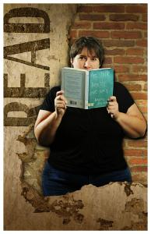
Gina Persichini is the Technology and Access Services Consultant at the Idaho Commission for Libraries. Having received her Master’s Degree from the University of South Florida School of Library and Information Science in 1995, Gina started as a trainer teaching librarians to incorporate online resources in library services. After six years with Florida’s multi-type library cooperatives, Gina relocated to Idaho in 2001 to join ICfL. As Technology and Access Services Consultant, Gina is focused on resource sharing and developing statewide library programs. She coordinates Libraries Linking Idaho (LiLI), a collaborative web-based service for Idahoans.

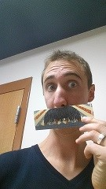
Nick Madsen, whose library career started as a trained monkey called a page, has been planning programs and events for elementary through high school students for the past several years. Working with STEAM tools like 3D printers, creating movies with teens in just a few hours, or hosting NERF battles after-hours, Nick is always on the lookout for the next crazy thing to attempt. Nick received his Master of Information and Library Science in December of 2013, and has enjoyed presenting at ILA, PNLA, and as a member of SPLAT (Special Project Library Action Team).

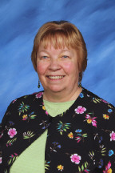
Cora Caldwell was introduced to children’s literature at the University of Oregon by Paulette Thompson. Since then she has worked for over twenty-seven years as a teacher-librarian. Cora received her Masters of Library Science from BYU. She is Chairperson of the Gooding Public Library Board. For the past seven years, she has been District Librarian for Gooding Schools and the Idaho School for the Deaf and the Blind. Cora has organized many collaborative projects between the school libraries and the public library. Cora was selected as Idaho School Librarian of the year in 2015. In addition to reading, Cora enjoys cooking, photography, traveling back roads, camping, and listening to KPLU jazz!

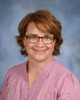
Gena Marker (B.S. Secondary Education, University of Idaho, 1996; M.A. Reading, Boise State University, 2008; M.L.I.S., University of North Texas, 2012), has been the Teacher-Librarian at Centennial High School in the West Ada School District for six years, and was a Language Arts and Social Studies teacher for 12 years prior to that. When she's not herding cats in the library, she's working on innovative Maker projects with her LABbies (Library Advisory Board) or advising CHS's foreign exchange students. She loves to sew, create, craft, travel on her summers off, and hopes to never again attend grad school.

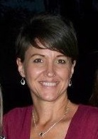
Sonja Humphries has been employed with the Jerome School District in Jerome, Idaho, since January, 2000. She has taught second grade as a reading support teacher, fifth grade, all subjects, and sixth grade language arts. For three years beginning in the fall of 2007, she held the position of the Jerome Middle School Librarian/Media Specialist. In the fall of 2010, she transferred in-district to Jerome High School as the Librarian/Media Specialist, serving approximately 900 students. In August of 2012, Sonja received a Master’s degree in Library Science from the University of North Texas and was a participant in the SWIM cohort. She is involved as an instructional partner at Jerome High School and participates on the school improvement committee.

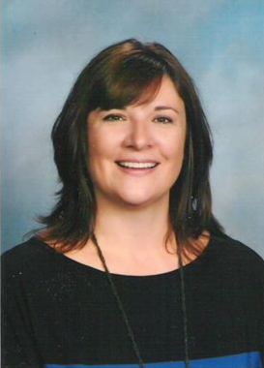
Tifani Young just completed her third year as the school librarian at Lakeland High School in Rathdrum, and prior to that, taught English for 20 years. She serves on the LILAC committee for the state of Idaho and holds a master's degree in English Education. She is most proud, however, of her daughter, a senior at Boise State; her son, a soon to be college sophomore; and her husband of 26 years. She enjoys reading, watching movies, cooking, and running.

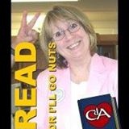
Bette Ammon, a librarian for over 30 years, has the best job in the world! She gets to connect people with information for education and for entertainment, and work with incredible people. Bette has a bachelor’s degree from the University of Northern Colorado and a master’s degree from Idaho State University. In her past lives she was a children’s and young adult librarian in Pocatello and Missoula – and a library director in Missoula for 8 years. She’s been the library director at Coeur d’Alene Public Library since 2005. Proud achievements for Bette include raising 2 kids (one is teaching 5th grade at Sorensen Magnet School for the Arts in Cd’A; the other is doing improve theater in Denver); being a Grammie to 4-year-old Max, and working in the most amazing library ever.
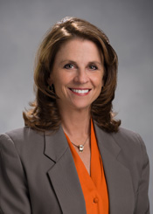
Kiki Miller has lived in Coeur d’Alene since 1975 and has served on the Coeur d’Alene City Council since 2014. One of her rolls as a councilman is sitting on the library board. In addition to her city government responsibilities, Kiki owns Kagey Company, Inc., a local marketing, publication and promotions firm, has served as a Coeur d'Alene Chamber of Commerce Executive Director, as a Women's Center Board Member (regional domestic violence organization) and has been named Volunteer of the Year for both the Coeur d'Alene and Post Falls Chambers. She also received Woman of the Year honors from the local Soroptimist organization and has volunteered or been appointed to several leadership roles for numerous organizations and nonprofits. Kiki and her husband have one son who just graduated from Lake City High School.
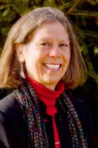
Ann Joslin is Idaho’s State Librarian. She has been with the Idaho Commission for Libraries since 1979, and was appointed State Librarian in 2005. Ann started her library career in public libraries in Montana and Utah before coming to the Commission as a reference librarian, and then as associate director to establish the library development division. She is the Past President of COSLA (Chief Officers of State Library Agencies). Ann holds bachelor degrees in English and History and a Master of Library Science from the University of Iowa. She lives in Eagle with her husband, 3 cats and lots of llamas.

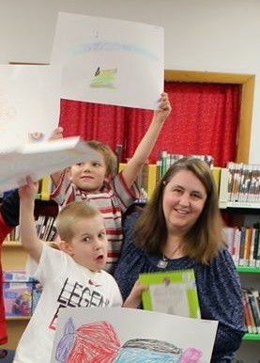
Carol Robinson is the District Librarian for Joint School District #171 in Orofino, Idaho. She taught secondary English for four years, and then elementary library for five years, and secondary library for nine years. In order to do this effectively, she received her teaching credential in English from University of California, Irvine and her second, specialist teaching credential in library media and a Master’s in Education with an option in school librarianship from Cal State, Long Beach. With 18 years of teaching experience, she then decided to apply for the Lilead Fellows Program. She represents the smallest district in the program with a mere 1,000 students; her district is located in north, central Idaho. The district’s focus is for students to reach their full potential and she is reinforcing this focus with a goal of infusing student learning with inquiry based research so students are prepared for the tough problems they will face in the future.

Erin Downey is the District Consulting Librarian at Boise School District in Boise, Idaho, where she is working to increase professional capacity of BSD’s 64 library staff members to support state learning and literacy initiatives. She is an active member of the Library Leadership Advisory Committee (LiLAC), a joint endeavor of the Idaho Commission for Libraries and the Idaho Library Association, and blogs for the Discovery Educators Network Leadership Council. You can find her on twitter at @ehdowney.
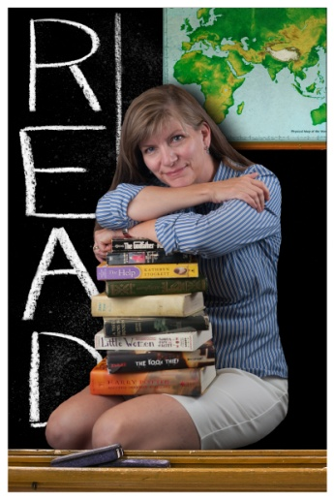
Jeannie Standal has been with the Idaho Commission for Libraries as the School Library Consultant since 2013. She holds a Bachelor of Business Administration from Boise State University, a Master of Library Science from East Carolina University, and was a Library Media Specialist in North Carolina before returning home to Idaho. Jeannie currently serves on the boards of ILA and PNLA. The best part of her job at the Commission is meeting school librarians from all over the state who do so much for Idaho’s students.

