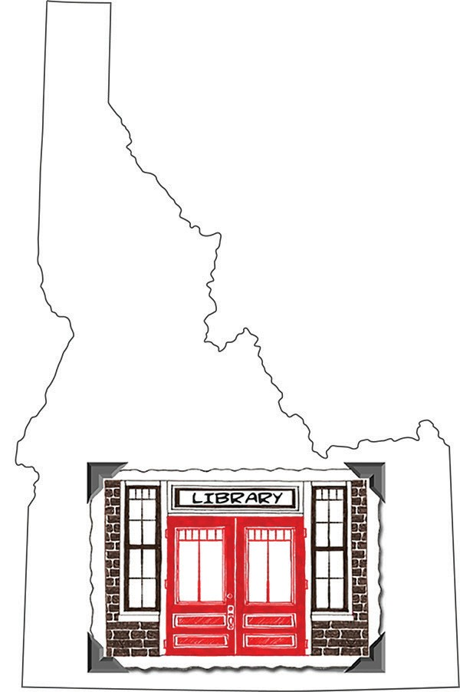Idaho Library Snapshot Day 2017 --- Comment Form

Snapshot Day
Insert Your Library Name or Logo Here

Please help us record how important your library is to the community. Tell us all of the reasons you came to the library today.

Name (Optional)
Town where you live

Please select all those that apply:
To check out a book, CD, and/or DVD Job Search
Games Research Homework Internet Use Computer Class
Email, Social Media, etc.
To Use Other On-Line Resources To Get a Library Card
To Attend a Meeting To Attend a Program
Other Other feedback is welcome:

Thank you for taking the time to participate!

