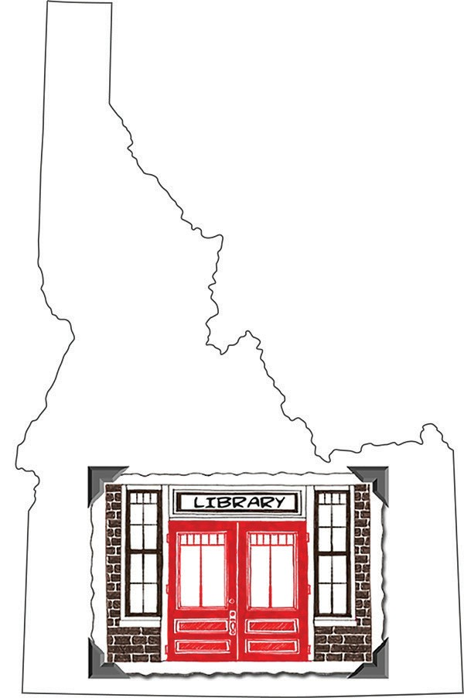Idaho Library Snapshot Day 2017

Snapshot Day
I, hereby grant (your library)
its legal representatives, agents, successors or assigns, permission to use my likeness in photographs, movie films, videotapes, DVDs, and/or sound recordings, or any part thereof in any and all of its publications, including website entries, without payment or any other consideration. I understand and agree that these materials will become property of (your library) and will not be returned.
I hereby irrevocably authorize the (your library) to edit, alter, copy, exhibit, publish, or distribute the photographs, movie films, videotapes, DVDs, and/or sound recordings, for the purposes of publicizing the (your library)
programs or for any other lawful purpose. In addition, I waive the right to inspect or approve the finished product, including written or electronic copy, wherein my likeness appears.
Additionally, I waive any right to royalties or other compensation arising or related to the use of the photographs, movie films, videotapes, DVDs, and/or sound recordings.

I hereby hold harmless and release and forever discharge the (your library) legal representatives, agents, successors, or assigns, from all claims, demands, and causes of action which, I, my heirs, representatives, executors, administrators, or any other persons acting on my behalf or on behalf of my estate have or may have by reason of this authorization.
I am 18 years of age and am competent to contract in my own name. I have read this release before signing below and fully understand the contents, meaning, and impact of this release.

(Signature) (Date)

(Printed Name)

For Persons Under 18 Years of Age:
If the person signing is under age 18, there must be consent by a parent or guardian, as follows:
I hereby certify that I am the parent or guardian of
named above, and do hereby give my consent without reservation to the foregoing on behalf of this person.
(Signature) (Date)

(Printed Name)

