Scavenger Hunt

For Families with Younger Kids
Print off and cut out the pictures below and place them around the library. Have families walk through the library and check off all the pictures they find on the attached list.
Tips for Success:
- Use painter’s tape to stick the pictures where you want without damaging any surfaces
- Make sure to place the pictures so that they are at eye-level for young children
- Let the kids be in charge of checking things off the list to promote the development of fine motor skills and print awareness
- After all the families have completed the scavenger hunt, have them turn in their lists and draw one entry at random to receive a prize

For Families with Older Kids
Print off and cut out the pictures below and place them around the library. Have families use clues from the attached scavenger hunt list to find the pictures and fill in the blank spots on the list.
Tips for Success:
- Use painter’s tape to stick the pictures where you want without damaging any surfaces
- If the clues on the scavenger hunt list don’t make sense for your library’s space, change them!
- Let the kids be in charge of writing down the names of items as they are found on the scavenger hunt list
- After all the families have completed the scavenger hunt, have them turn in their lists and draw one entry at random to receive a prize

Scavenger Hunt Pictures

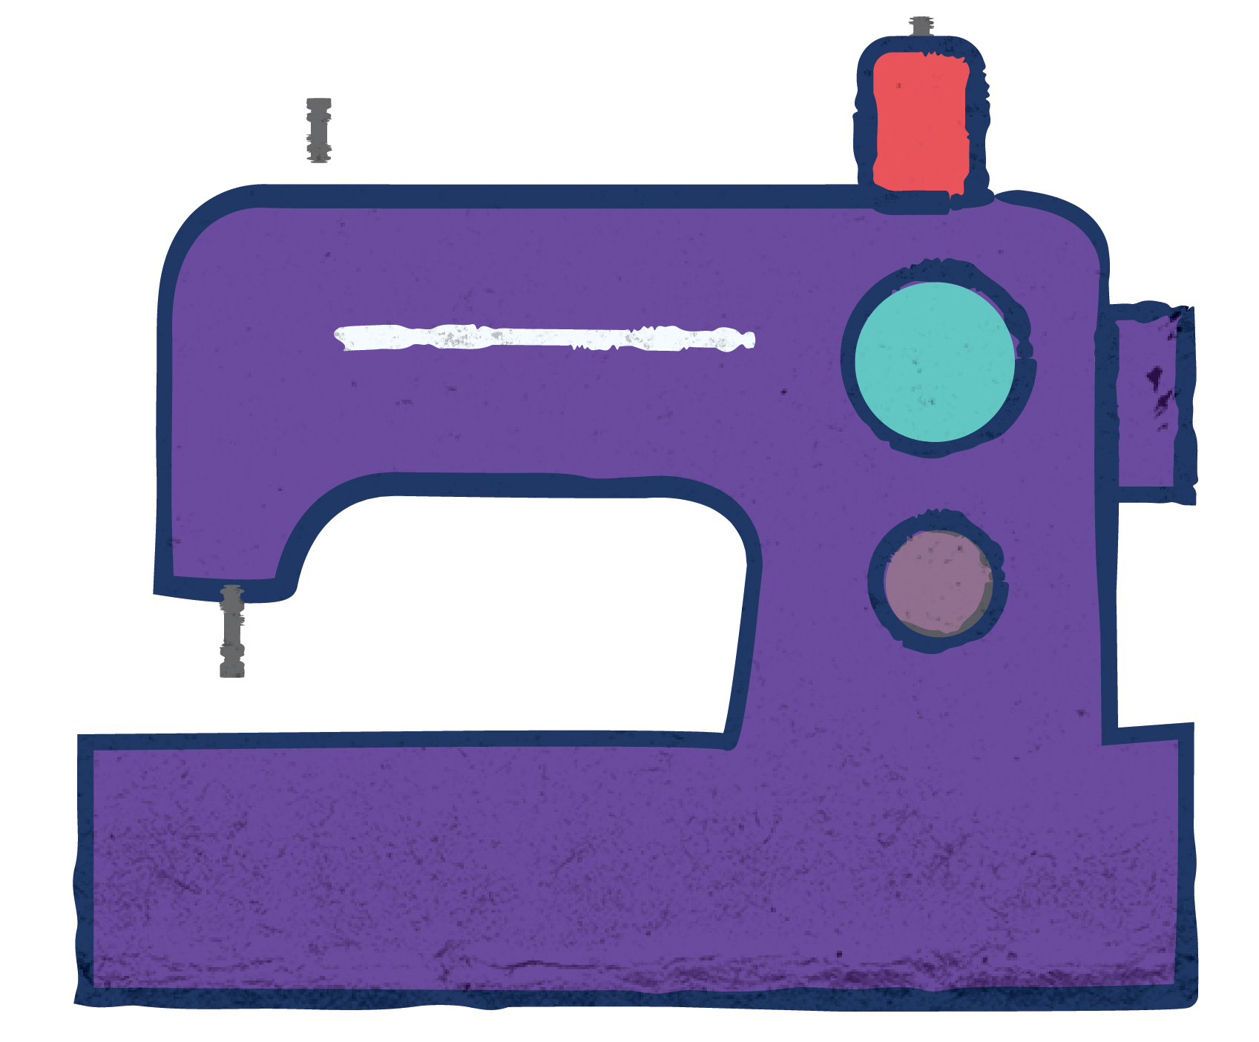
Board Books
Sewing Machines
646.2044

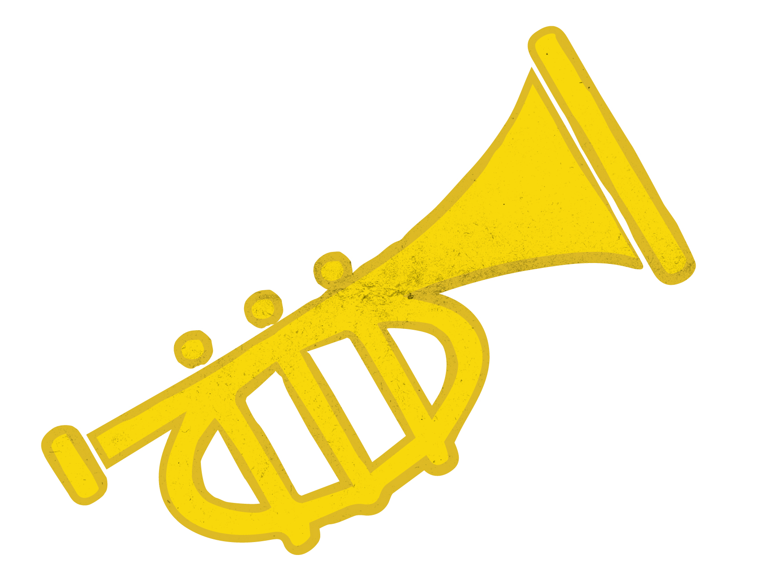
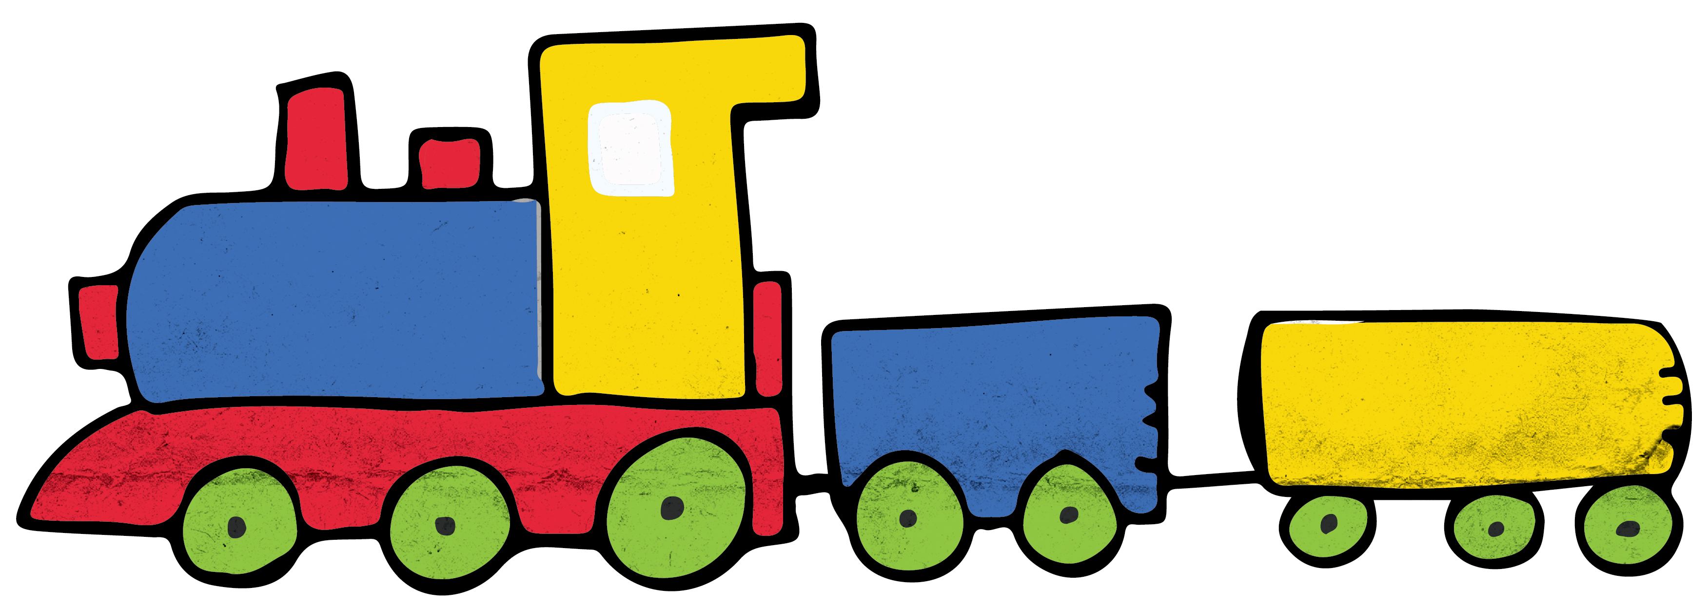
Newspaper
Music
780
Trains
625.1

Find It! Scavenger Hunt

Can you find these images?
Find It! | Put and X in the box when you find the picture

Find It! Scavenger Hunt

Use these clues to find pictures of five items hidden throughout the library. Write down the name of the picture in the space provided [Note to libraries: these are generic clues that you can modify to fit your space]

When you want to find out what happened in our community yesterday, you can read this:

What type of books are found in the 780’s section of the library?

Choo choo! These books can be found in the kid’s non-fiction section, under the number 625.1

Babies LOVE these books – they are easy to hold and pages won’t rip!

Uh oh! Time to repair that hem – books in the 646 section could help

