Bright Futures: Family Outreach Talking Points & Resources
- Time spent in and out of school: (can supplement by handing out Summer Slide Brochure, see below)
  - (If you have room, consider using crepe paper visual. Can also open Summer Slide Brochure to show line graph.)
  - Talking point: Kids who only read in school will rarely be great readers. Time spent in school is usually enough time to learn to read but not nearly enough time to become proficient readers.

- Summer Learning Loss: (can supplement by handing out Summer Slide Brochure)
  - Talking point: Children who do not read over the summer months can lose as much as three months of reading achievement. This is equal to almost a third of an entire school year!

- Consistent reading routine:
  - Talking point: Studies show that maintaining a consistent reading routine over the summer months can be as simple as reading with your beginning or pre-reader for 15 – 20 minutes each day, or encouraging your independent reader to read four to five books before school begins in the fall.
  - Optional talking point: Children need to hear books being read as much as reading on their own—consider audio books, and family read-alouds; encourage those providing care to your child during the day to read aloud to them, too (siblings, grandparents, child care providers, other adults).

- Self-selection of materials:
  - Talking point: Children generally read more when they are excited about what they are reading. Your child’s identified reading level can be a good place to start, but children are more passionate about reading when they choose materials that interest them or that are popular, and that don’t require them to take a test afterward.
  - Optional talking point: Let children choose magazines, graphic novels, gaming books, and comics in addition to traditional books.

- Library programs and access to books:
  - Talking point: (Let parents know how they can access free books in your community—the library, school library, Little Libraries in parks, etc.)
  - Talking point: (Explain library’s summer reading program and how to register)
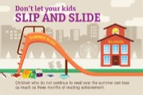
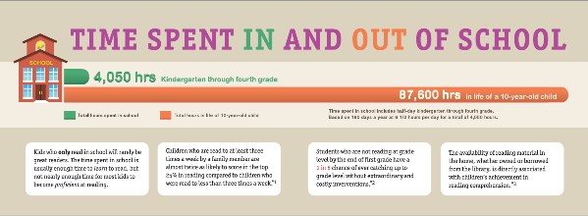
We wanted to keep this simple in case you are trying to catch parents on the run. If you’ve got a captive audience and a little more time, please consider doing the visual demonstration, using “children who continue reading over the summer” and “children who do not,” rather than “middle income” and “low-income children.” There are also some other great talking points you can add!
See http://libraries.idaho.gov/page/summer-reading-resources for the following:
- Script: Visual Demonstration Activity showing Summer Learning Loss
- Videos
- Summer Slide Brochure (free--order in packs of 50)→→→
- Research Points
- And much more!

