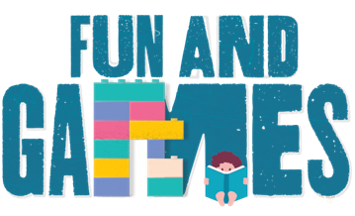
Idaho Family Reading Week 2020
- At Home Game & Activity Ideas -

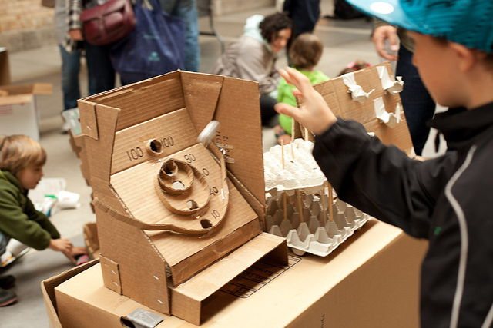
- Cardboard Challenge: Watch this video about Caine’s Arcade – a boy’s cardboard arcade that inspired the world – then do your own cardboard challenge by the Bay Area Discovery Museum: https://bayareadiscoverymuseum.org/activity/cardboard-challenge

- PBS’ “Full-Time Kid”: Learn and play at home with Maya from “Full-Time Kid” by PBS. Some examples of fun games/activities include:
  - Learn how to make shadow puppets: https://www.pbs.org/video/full-time-kid-how-make-shadow-puppets/
  - Learn how to beatbox and breakdance: https://www.pbs.org/video/full-time-kid-elmo-learns-beatbox-breakdance/
  - Learn how to solve a Rubik’s Cube: https://www.pbs.org/video/full-time-kid-how-solve-rubiks-cube/
  - Fun with Rubber Bands: https://www.pbs.org/video/full-time-kid-fun-rubber-bands/
  - Learn how to play the Cup Game: https://www.pbs.org/video/full-time-kid-cup-game/
  - Learn 3 easy dance moves: https://www.pbs.org/video/full-time-kid-3-easy-dance-moves/

- Reading Challenge: Use Idaho Family Reading Week as a kick-off to your own Fall/Winter Reading Program or challenge:
  - Use ICfL’s 2013 Winter Reading Program (WRP) game board and certificate of completion - there are no dates on this and it can easily be re-used:
    - http://libraries.idaho.gov/files/CD_List-of-Contents.html
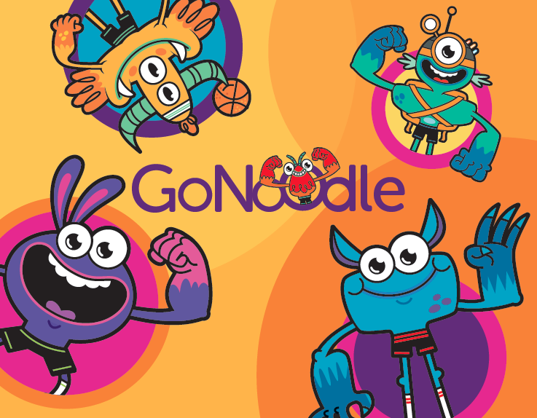
  - Use the reading challenge handout created by Every Child a Reader: Children’s Book Week reading challenge - it’s ready to go!
  - See an example from an Idaho public library who created their own winter reading program last year: https://www.ifpl.org/winter-reading/

- Movement: Go Noodle games and activities: https://www.gonoodle.com/

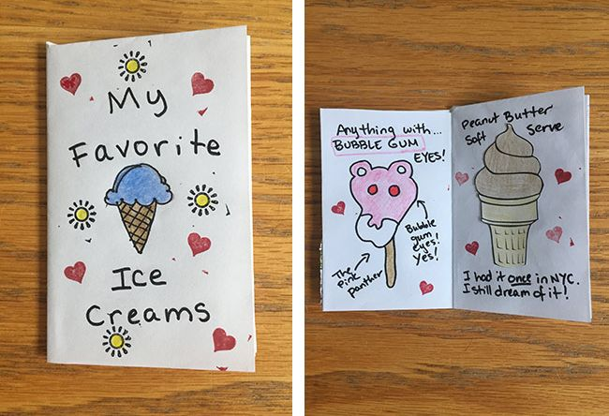
- Make a Zine: Make your very own homemade magazine - referred to as a “Zine.” Here’s one example: “How to Make a Zine: A Kid-Friendly Guide”, by Celia C. Perez, author of The First Rule of Punk

- Make a Sports Arena: Make your own soccer, football, or basketball game/court:
  - Make your own mini basketball hoop!
  - Make your own shoebox foosball game! or this try this one!
  - Make your own marble maze! - Or see our special activity video created by Salmon Public Library with two activity demonstrations on the Family Reading Week page of our website: https://libraries.idaho.gov/rtm/idaho-family-reading-week/

- Digital Scavenger Hunts/Searches:
  - “I Spy Digital Scavenger Hunt” (created by the Salt Lake County Library)
  - “Hide & Seek Digital Scavenger Hunt” (created by the Salt Lake County Library)

- Arts & Crafts:
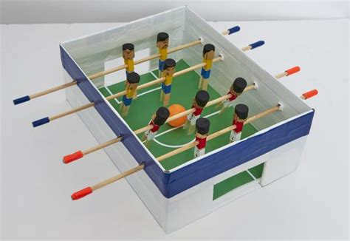
  - Ready Set Draw! – videos from Kit Lit TV by children’s book illustrators as they reveal their secrets to drawing the characters in their books: https://kidlit.tv/category/ready-set-draw/. Check a few of these out:
    - How to draw a big cat from I Am A Cat by Galia Bernstein
    - How to Sam the mouse from Library Mouse
    - How to draw a T Rex from Don’t Ask a Dinosaur
    - How to make a collage
  - Summer Road Trip, a Smithsonian At-Home Activity Guide: https://drive.google.com/file/d/1cMqb9-PNbLPidEF-9jSm9CjlDs2Efksi/view
  - Make a Pan Flute and write your own flute song: https://www.youtube.com/watch?v=zKFyiA4lklY
  - Origami Folding: Share these links to fold some of Tom Angleberger’s origami creations like Origami Yoda, Darth Paper, Fortune Wookiee and more! https://www.youtube.com/playlist?list=PLA50E07CCCD9669C4

9) Other Stuff To Do:
Tom Angleberger’s site also has a great “Stuff To Do Round-Up” with loads of ideas: https://origamiyoda.com/2020/07/stuff-to-do-round-up/

