|  |  |
| --- | --- |
| ­­ | **Title**  Paragraph text Paragraph text Paragraph text Paragraph text Paragraph text  Paragraph text Paragraph text Paragraph text Paragraph text Paragraph text  Paragraph text Paragraph text Paragraph text Paragraph text Paragraph text  **Title**  Paragraph text Paragraph text Paragraph text Paragraph text Paragraph text  Paragraph text Paragraph text Paragraph text Paragraph text Paragraph text  Paragraph text Paragraph text Paragraph text Paragraph text Paragraph text |

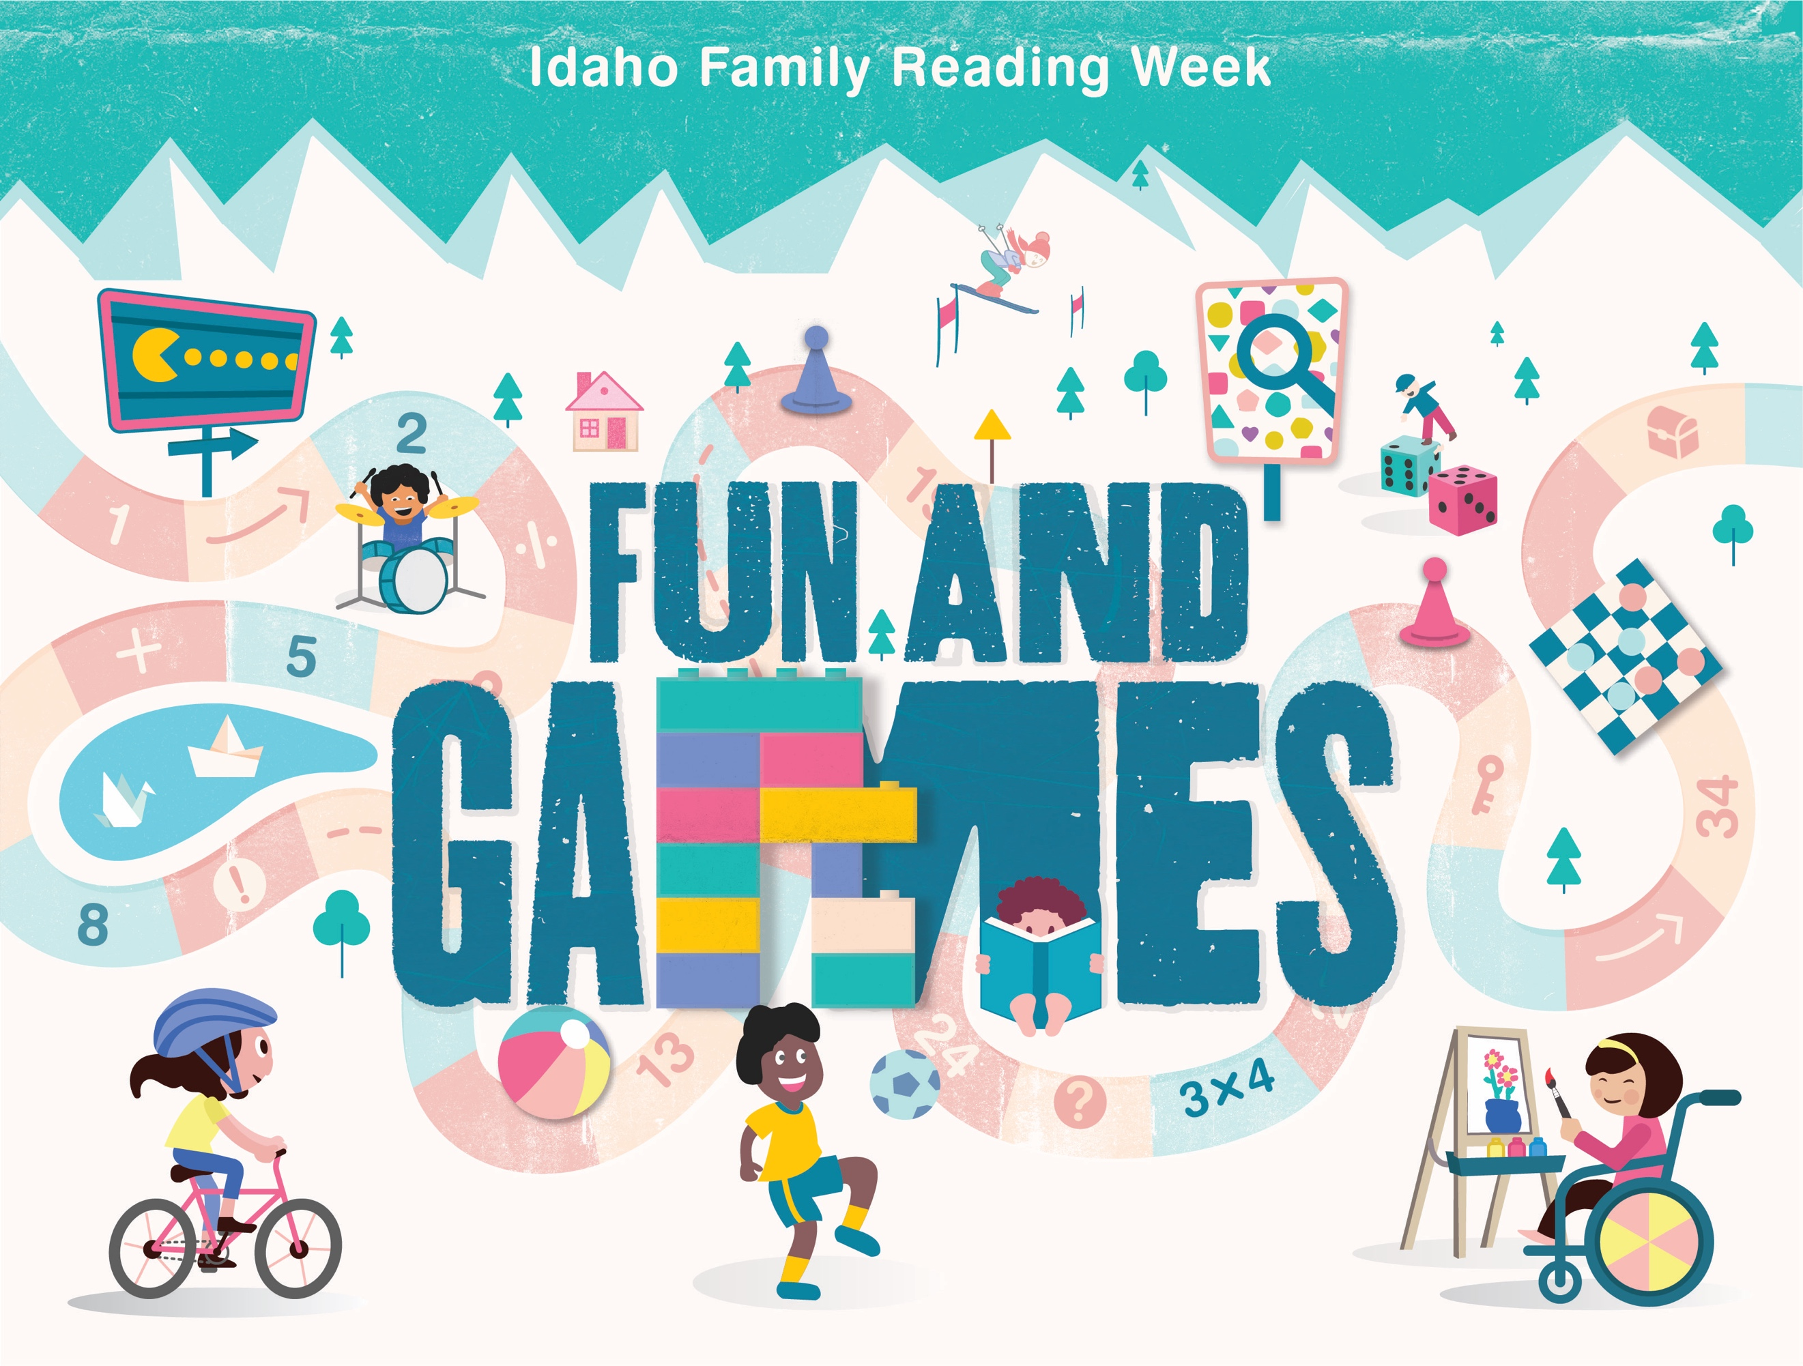V