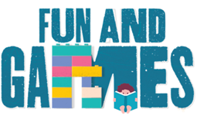
Idaho Family Reading Week 2020
Literacy Game & Activity Ideas

- Author website game links – examples:
  - “Creator Corner with KidLit TV” - This campaign commemorates the 100th anniversary of Children’s Book Week, and the three-to-five minute long videos feature well-known and popular children’s book authors and illustrators speaking about their favorite character creations: https://everychildareader.net/cbw/creator-corner/
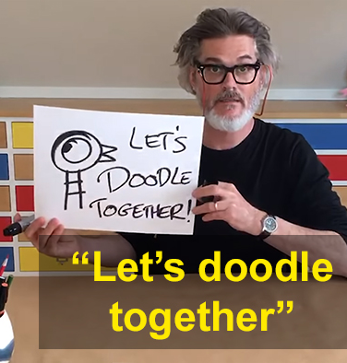
  - Ready Set Draw! – videos from Kit Lit TV by children’s book illustrators as they reveal their secrets to drawing the characters in their books: https://kidlit.tv/category/ready-set-draw/. Check a few of these out: How to draw a big cat from I Am A Cat by Galia Bernstein
  - Lunch Doodles with Mo Willems: https://www.youtube.com/playlist?list=PL14hRqd0PELGbKihHuTqx_pbvCLqGbOkF
  - Authors Everywhere: https://www.youtube.com/channel/UCowhHSUaWp3KJDcuI0nR0vw/featured
  - Who Was book series – website includes the Who Was Adventure Game app (free download), activity sheets, and the Who Was History Bee: http://www.whowasbookseries.com/

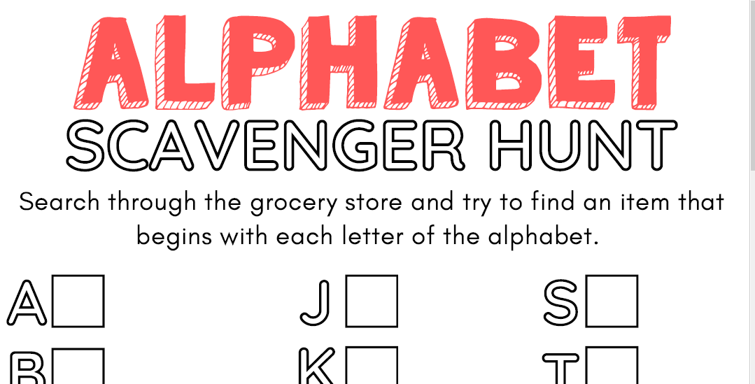
- PBS Kids Reading Games: https://pbskids.org/games/reading/

- Grocery Store Letter/Color Search – Utilize these alphabet/color boards for kids and families to search for their letters while at the grocery store, or create a custom board for your community, school, library, or other business in your area.

- Book Characters 20 Questions: Sort of like a literary Guess Who. Draw a book character name from a hat and the kids get 20 chances to narrow it down. Depending on your group, the last guesser could draw the next name.

- Reading BINGO Game – Consider adapting one of these Bingo Card examples for your own library or at home program. The kids could utilize the entire month of November to complete their Bingo game. Or mix up reading with other fall-related activities, like this example.

- Book Diagram: Kid practice diagramming a book they love and sharing it with others (from Every Child a Reader): https://everychildareader.net/wp-content/uploads/2020/02/CBW2020Poster_CarinBerger_Diagram.pdf
- Story Time From Space: So many great children’s books have been read from space by true astronauts! Check it out: https://storytimefromspace.com/
