*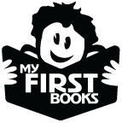***2021-2022 My First Books**

**Community Partner Information**

[**https://form.jotform.com/icfl/MFB-Partner-Info-Form-21-22**](https://form.jotform.com/icfl/MFB-Partner-Info-Form-21-22)

Dear Community Partner:

Thank you for your interest in participating in the My First Books program with your local library.

To be considered as a partner for the 2020-2021 school year, please follow these steps:

1. **Obtain permission** from school principal or organization’s director.

2) **Go to this link** and provide the information requested [**https://form.jotform.com/icfl/MFB-Partner-Info-Form-21-22**](https://form.jotform.com/icfl/MFB-Partner-Info-Form-21-22)

*(No private information about individual children or families will be collected, and any information obtained from this form will remain confidential; information is used to ensure program eligibility, as well as your understanding of all program requirements.)*

3) **Sign** the electronic form and click **submit** by the date your library specified below.

Once submitted, this information will be sent to your library partner, who will transfer your enrollment information to their official application. They must submit their application no later than April 20, 2020. Failure to submit your organization’s information before that date may jeopardize your eligibility to participate in the program for the upcoming year.

A copy of your submission will also be sent to the Idaho Commission for Libraries to ensure a signed copy of your submission is on file with the library's application.

To learn more about the My First Books program, visit our My First Books program website: https://libraries.idaho.gov/rtm/my-first-books/ or see reverse of this handout.

**Deadline to submit partner information:** ____________________________________________

***You will need to include the following information in your electronic form:***

**Public Library Partner:** ____________________________________________________________

**Public Library Partner email address:** ­­­­­­­­­­­­­­­­­­­­­­­­­­­­­_______________________________________________

**Note:** If you are a school or school district, please provide your **Free/Reduced lunch rate** on the electronic form. If you are a private daycare or preschool, please provide your **ICCP rate** (Idaho Child Care assistance funds). Head Starts and Developmental Preschool Programs do not need to provide this information.

*My First Books is sponsored by Read to Me, a program from the Idaho Commission for Libraries, a state agency. Books and program materials are funded with state funds, as well as funds from the Institute of Museum and Library Services.*

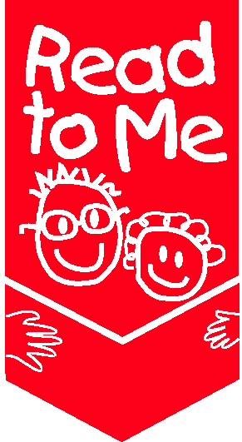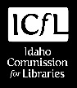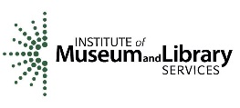



***Background Information for Community Partners***

**My First Books Program Objectives:** The Idaho Commission for Libraries has established the following outcomes for the children and families participating in My First Books.

Midvale Preschool

1. **Participating children increase their access to books by starting a home library.**
2. **More underserved families have library cards and use the public library.**
3. **Participating children increase early literacy skills.**
4. **Parents of participating children increase their knowledge about early literacy.**
5. **Parents of participating children increase home literacy activities.**
6. **Libraries strengthen community partnerships.**

**Project Description and Requirements:**

Please read through the following before you decide to become a My First Books partner. Your library can answer any questions you may have.

* Children are enrolled in organization's or school's program on a daily or consistent basis from September through May. Drop-in programs or summer programs do not qualify (i.e., Boys and Girls Club, Migrant Seasonal Head Start, etc.*)
* A representative from the library will visit the organization on a monthly basis to conduct storytimes, distribute free books to the children, and provide information about early literacy skills for teachers and parents. There is no financial obligation on the part of the partner organization.
* All children in the **classroom** (school, daycare, or preschool) must be included in the monthly distributions, rather than just a subset of identified children (i.e., struggling readers, ELL, etc.).
* Early Head Start programs in which children attend on-site programs are eligible to participate; Early Head Start programs that are home-visiting programs are **not** eligible because a requirement of the program is for library staff to have face-to-face contact with the children each month.
* Books are distributed to the **same children every month**. Organization’s staff will notify the library of changes in enrollment as early as possible in order to ensure every child receives the book of the month.
* Organization’s staff remains present during monthly library visits and assists with book distributions.
* Organization’s staff ensures the monthly parent newsletter, “The Bookworm,” is sent home with the book.
* Each library must provide one early literacy workshop for parents of participating children or one family event held for My First Books families. The partner organization will be asked to support this event by promoting it to parents. In addition, partners may also elect to attend, host, assist in planning the event, etc.
* This project is evaluated annually by the Idaho Commission for Libraries. Partner organizations agree to distribute and collect the “My First Books Parent Survey” at the end of the eight-month program (April/May) and return to the library representative.