Geography, STEAM and Map Making Ideas
for “Adventure Awaits” Family Reading Week Event

Travel/Road Trip Game:
Display several books about transportation, travel, states and cities.
Print out US Map - https://commons.wikimedia.org/wiki/File:Map_of_USA_showing_state_names.png
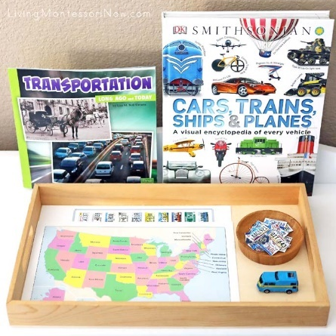
Print out US license plate art - https://www.imom.com/road-trip-games-for-summer/#.XNzZ5Y5KiUk
Print out 2 copies of the license plates and one 8½x11″ copy of the map. Cut apart all the license plates from one copy of the printable. Keep the second page of license plates together. I placed everything on a tray or a table along with a miniature vehicle.
Instruct children and their family members to pretend they are traveling the U.S. in the miniature vehicle. Have the children take turns closing their eyes and drawing a license plate from the bowl. Place the license plate on the page of license plates and drive the mini-vehicle to that state on the map.
See more Montessori-Inspired Travel Activities (free): https://livingmontessorinow.com/free-travel-printables-and-montessori-inspired-travel-activities/
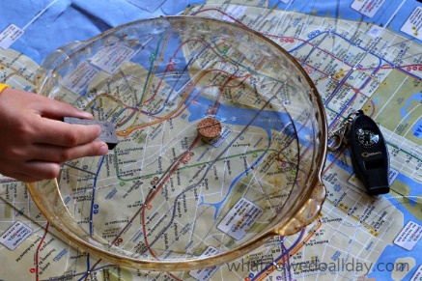

Map Science with Your Homemade Compass:
https://www.whatdowedoallday.com/map-science-with-homemade- compass

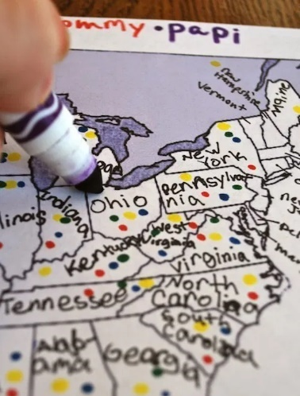

Kids Take a Poll and Learn About Geography –
Data Visualization Activity:
https://kidworldcitizen.org/kids-take-a-poll-which-statescountries-have-you-visited/

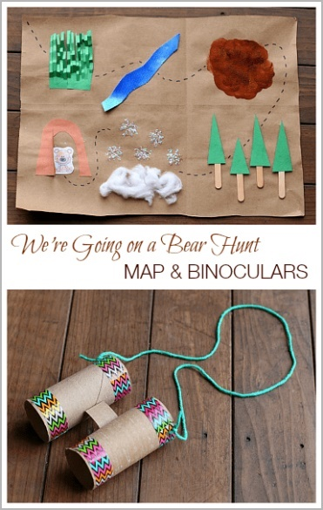
Three Map Making Activities:
- We’re Going on a Bear Hunt Map & Binoculars Children’s Book Activities: https://buggyandbuddy.com/going-bear-hunt-map-activity/

- Make your own Treasure Map: http://www.busybeekidscrafts.com/Pirate-Map.html

- Make your own Neighborhood Map or Imagine Your Own Desert Island:
https://news.urbansitter.com/blog/crafty-kids-how-to-make-map-of-your-neighborhoodand-your-imagination
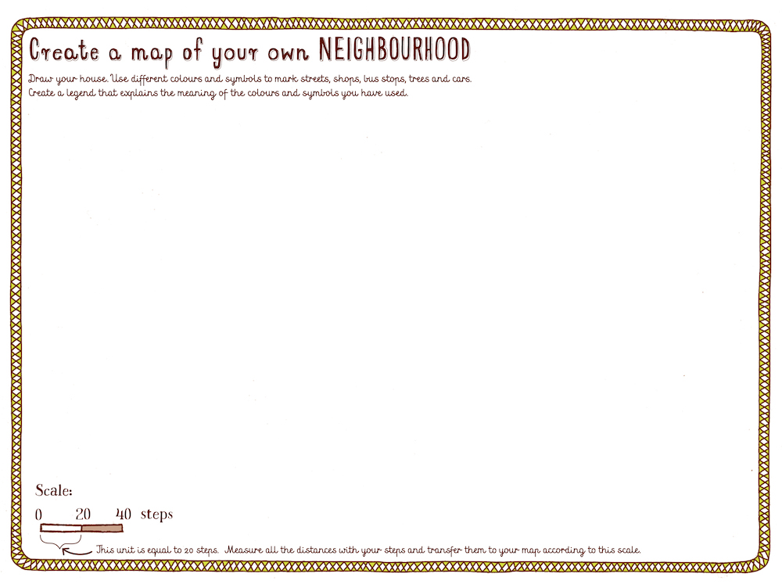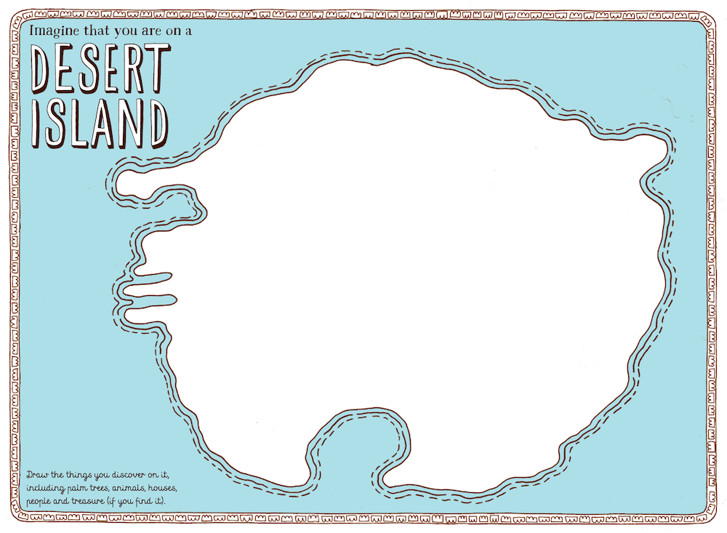
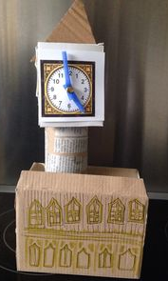
Famous Landmarks STEAM Challenge:
https://www.destinationimagination.org/blog/famous-landmarks-steam-challenge/
Or conduct your very own Cardboard Challenge of Famous Landmarks – invite kids of all ages to build any famous landmark using cardboard, other recycled materials and their imagination!
(Tip: Provide a poster board full of images of 10-20 famous landmarks to get the kids inspired.)
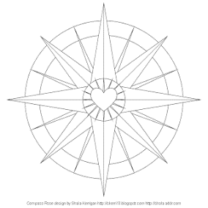
General Map resources:
Printable vintage maps: https://www.remodelaholic.com/20-free-vintage-map-printable-images/
Compass Rose coloring activity sheet: http://www.donteatthepaste.com/2009/05/compass-rose-coloring-page.html

