The University of Idaho McClure Center for Public Policy Research and the Idaho Association for the Education of Young Children (IdAEYC) invite you to a town hall meeting (about 90 minutes) in your community.
This town hall is intended to gather information on your experiences, challenges and successes connected to services that support young children and childcare in your community.
The input from stakeholders in each community will guide the future of services, resources and programs in Idaho.
RSVP
Questions? Contact us: mcclurecenter@uidaho.edu
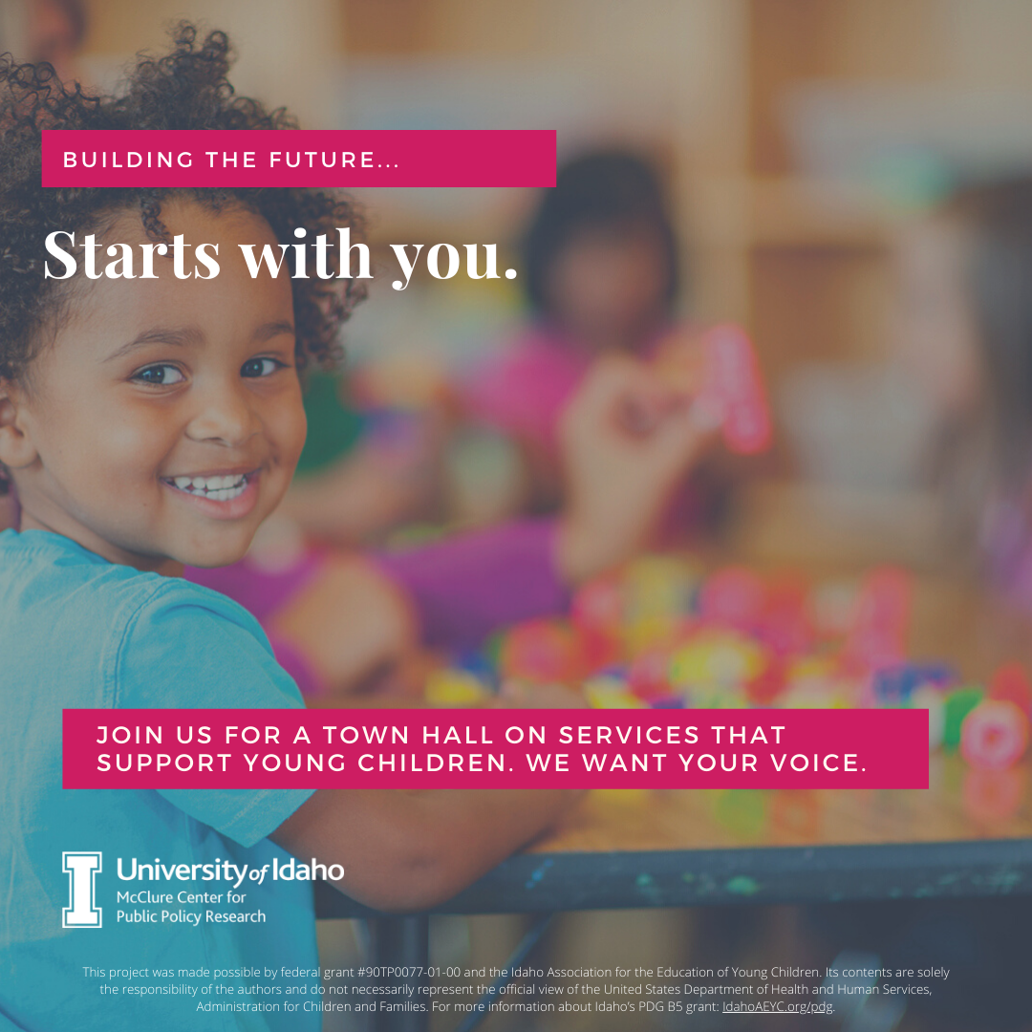
The University of Idaho McClure Center for Public Policy Research and the Idaho Association for the Education of Young Children (IdAEYC) invite you to a town hall meeting (about 90 minutes) in your community.
This town hall is intended to gather information on your experiences, challenges and successes connected to services that support young children and childcare in your community.
The input from stakeholders in each community will guide the future of services, resources and programs in Idaho.
RSVP
Questions? Contact us: mcclurecenter@uidaho.edu

The University of Idaho McClure Center for Public Policy Research and the Idaho Association for the Education of Young Children (IdAEYC) invite you to a town hall meeting (about 90 minutes) in your community.
This town hall is intended to gather information on your experiences, challenges and successes connected to services that support young children and childcare in your community.
The input from stakeholders in each community will guide the future of services, resources and programs in Idaho.
RSVP
Questions? Contact us: mcclurecenter@uidaho.edu

