Recommended Reading List for Idaho Family Reading Week 2019

Picture Books:
Bear Came Along, by Richard Morris, 2019
The Skydiving Beavers: A True Tale, by Susan Wood, 2017
Dragon Knight, by J.R. Krause, 2019
Hey Grandude! by Paul McCartney, 2019
Ocean Meets Sky, by Terry Fan, 2018
Drawn Together, by Minh Lê, 2018
All the Way to Havana, by Margarita Engle, 2017
Camp Tiger, by Susan Choi, 2019
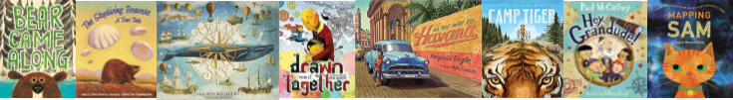
Mapping Sam, by Joyce Hesselberth, 2018
Beginning Readers:
Road Trip with Max and His Mom, by Linda Urban, 2018
Princess in Black series, by Shannon Hale, 2015 – present
Mercy Watson series, by Kate DiCamillo, 2011 – present
Dragon Masters series, by Tracy West, 2014 – present
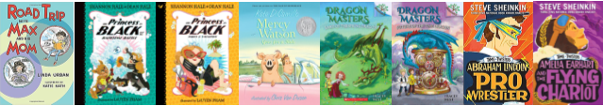
Time Twisters series, by Steve Sheinkin, 2018-2019

Intermediate Readers:
Treasure Hunters series, by James Patterson and Chris Grabenstein, 2013 – present
The Infinite Lives of Maisie Day, by Christopher Edge, 2019
Ms. Bixby’s Last Day, by John David Anderson, 2017
The Unexpected Life of Oliver Cromwell Pitts: Being an Absolutely Accurate Autobiographical Account of My Follies, Fortune, and Fate, by Avi, 2017
Some Places More than Others, by Renée Watson, 2019
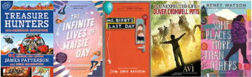

Nonfiction:
Homes in the Wild: Where Baby Animals and their Parents Live, by Lita Judge, 2019
World’s Strangest Places by Lonely Planet Kids
The Atlas Obscura Explorer's Guide for the World's Most Adventurous Kid
Crossing on Time: Steam Engines, Fast Ships, and Journey to the New World, by David Macaulay, 2019
America’s National Parks (Lonely Planet Kids), 2019
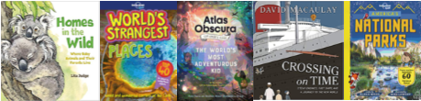

Classics:
Picture books:
Where the Wild Things Are, by Maurice Sendak
Oh, the Places You’ll Go, by Dr. Seuss
The Tale of Peter Rabbit, by Beatrix Potter
Winnie-the-Pooh, by A. A. Milne
Chapter Books:
Bridge to Terabithia, by Katherine Patterson
A Wrinkle in Time, by Madeleine L’Engle
The Lion, the Witch, and the Wardrobe, by C.S. Lewis
The Secret Garden, by Frances Hodgson Burnett
Alice’s Adventures in Wonderland, by Lewis Carroll
Around the World in 80 Days, by Jules Verne
The Wonderful Wizard of Oz, by Frank Baum
Treasure Island, by Robert Louis Stevenson
