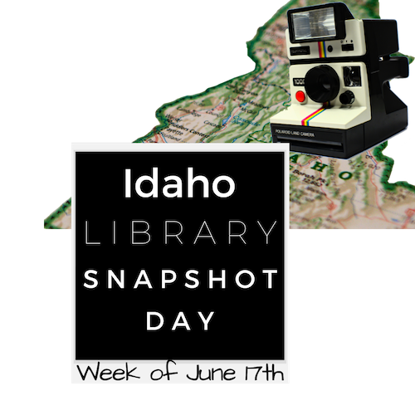
Idaho Library Snapshot Day 2019
Comment Form

<< Insert your Library Name and/or Logo Here >>

Please help us record how important your library is to the community. Tell us all of the reasons you came to the library today. Thank you for helping us improve our service.

Name (optional): __________________________________________________________

Town where you live: ______________________________________________________

Please select ALL that APPLY:

To check out a book. Computer class.
To check out a CD. Email, social media, etc.
To check out a DVD. To use LiLI.org.
Job search. To use other online resources.
Game(s). To get a library card.
Research. To attend a meeting.
Homework. To attend a program.
Internet use. Other.

Other feedback is welcome:
_________________________________________________________________________

_________________________________________________________________________

_________________________________________________________________________

_________________________________________________________________________

_________________________________________________________________________

Thank you for taking the time to participate!!

