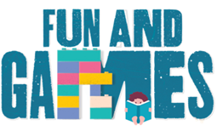

Idaho Family Reading Week 2020
“Fun & Games” Book Recommendations

Utilize these themed-book recommendations to create your own bookmarks, sort by age group, send home as a parent flyer, create a library display, or as a recommended check-out list for shared family reading.

What to Do with a Box by Jane Yolen
Not a Box & Not a Stick by Antoinette Portis (for littles)
A Stick is an Excellent Thing by Marilyn Singer
Rosie Revere, Engineer by Andrea Beatty
Mabel and Sam at Home by Linda Urban
Star Jumper: Journey of a Cardboard Genius by Frank Asch
This Is My Dollhouse by Giselle Porter
Christina Katerina and the Box by Patrica Lee Gauch
Origami Yoda (series) by Tom Angleberger
Windows by Julia Denos
Blackout by John Rocco
The Birthday Box by Leslie Patricelli (for littles)
Chalk by Bill Thomson
How to Code a Sandcastle by Josh Funk

**For information regarding publisher permissions for virtual storytimes for the books listed above, please see the “FRW Storytime Ideas & Resources” document on our website under: “Activity Ideas/Storytime Resources”

