BLOCKS
BOOKS
COMPUTERS
CRAFTS
DATABASES
DRAMATIC PLAY
EARLY LEARNING
EBOOKS
EVENTS
EXPERTS
FACTS
FRIENDS
FUN
GAMES
INSTRUMENTS
INTERNET
MAGAZINES
MAKERSPACE
MEETING ROOMS
MUSIC
PRINTERS
PROGRAMS
PUPPETS
PUZZLES
ROBOTS
SOURCES
STORYTIMES
SURPRISES
TECHNOLOGY
THEMED KITS
TOOLS
TOYS

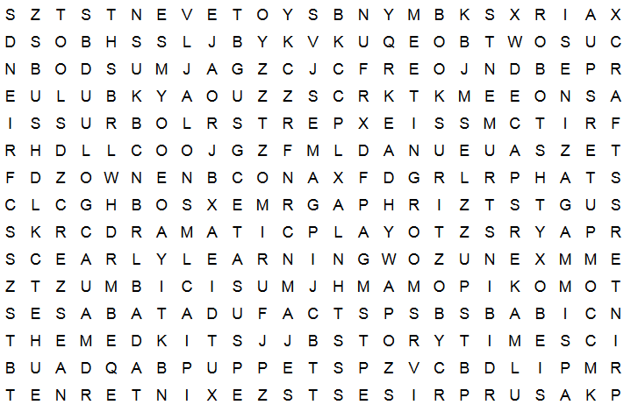
My Name ___________________________________________
My Library’s Name: ___________________________________
