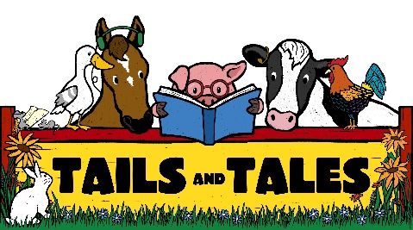
2021 Idaho summer reading report:
preview of questions

Please submit your actual report online at https://form.jotform.com/icfl/2021-idaho-SRP-report by September 15, 2021.
We understand that many of your programs were affected by the pandemic and safety measures. Please fill out this report the best you can. If you did not host a program this year, please choose “no” on the question regarding whether you hosted a program, and you will skip to the end of the report.
Questions marked with an asterisk (*) are required. The others are optional, but responses are always appreciated.
*1) Did your library branch host a Summer Reading Program (SRP) this year? (yes/no)
*2) Are you submitting this report for Bookmobile only? (If yes, you will bypass the section for participation in "in-house" Summer Reading Program and go directly to Outreach. Your SRP in-house participation numbers should be submitted to your main library or relevant libraries.)
SECTION 1: PARTICIPATION

*3) Who can participate in your Summer Reading Program? (check all that apply)
Babies/toddlers; Preschool children; Elementary school children; Young teens - middle school or junior high; Older teens - high school; Adults
4) “In-house” Participation:
- "In-house" Program: This is your regular library program, however you set that up this year (reading logs, activities, etc.)
- Children did not need to "complete" your program, only "participate" (according to how your library defined "participation" this year).
- For this report we are not counting attendance at programs (virtual or in-person). However, you will need to report this on your annual library statistics in the fall.
- We acknowledge that this is not a typical year, so please do the best you can to estimate this number.
*Please enter the number of children ages 0 to 18 who participated in the program that your library defines as its "Summer Reading Program."
Briefly list what your library required for "participation."
5) Outreach:
If you visited summer nutrition programs, daycares, schools, clinics, events, etc. to host a library event or hand out books during the summer months, we would like your best estimate of the number of children and teens you made contact with and delivered the message, "Read over the summer!"
One way to do this would be to count the number of books distributed or the number of reading logs distributed at outreach sites. Please do your best to count these children/teens only once.
Note: Due to the pandemic we acknowledge that you many not have been able to provide books or services at outreach sites face-to-face; please estimate your number to the best of your ability.
*Please enter the number of children ages 0 to 18 that you reached during community outreach events. If you did not do any kind of outreach over the summer, please insert the number 0.
6) If your library provided daily or weekly scheduled visits, please indicate how/where that outreach programming took place (check all that apply):
Schools; Parks; Child Care or Community Centers (daycares, Boys/Girls Club, etc.); Churches; Mobile library, multiple locations (bookmobile, bus, wagon, etc.); other
*7) How did your library formally assess the quality and effectiveness of its SRP? (check all that apply)
Surveys to children; Surveys to teens; Surveys to parents; Surveys to adult SRP participants; Surveys to teachers/principals/school staff; Surveys to volunteers; Surveys to community or outreach partners; Focus groups; Partnership with school or district to collect student data; Comment cards at programs and outreach events
OPTIONAL: If you formally assessed your program this year, what were some of the results/outcomes/conclusions of your evaluation?
SECTION 2: PARTNERSHIPS

8) Please tell us about your summer reading partners (check all that apply)
Schools; Homeschool Organizations; Private Businesses; Nonprofits; Churches/Religious Organizations; Head Start; WIC/Food Banks or Pantries; Community Centers (YMCA, Boys/Girls Club); Daycares, Preschools; Hospitals/Health Clinics; 4-H; Summer Meal Programs
9) Please check any that apply if you partnered with Summer Meal Programs:
Our library hosted summer meals or snacks at the library or through our Bookmobile.
Our library did outreach at sites hosting summer meals or snacks.
Our library partnered with a summer meal program to provide books at meal pick-up sites or backpack programs (no face-to-face contact with families).
10) Due to the pandemic, did you form any new partnerships, or strengthen any existing partnerships to serve children in new or different ways?

Please continue…

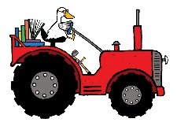
SECTION 3: COLLABORATIVE SUMMER LIBRARY PROGRAM (CSLP)

*11) For our summer reading theme we used:
CSLP theme: Tails and Tails
Other theme: (list)
No theme
*12) ICfL provided a 2021 CSLP program manual to every library that submitted its 2020 summer reading report. Please rate the quality and effectiveness of the program manual. (rating scale)
13) ICfL provided each library with posters to help promote its summer reading program. Please indicate how useful these posters were to your library: (rating scale)
14) Optional comments about program manual or posters:
15) Optional comments about CSLP or their program materials:
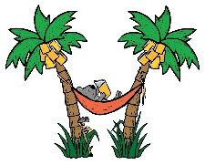
SECTION 4: YOUTH EXPLORER PASSES AND SCOTTISH RITE BOOKS

16) The ICfL and Idaho Department of Parks and Recreation (IDPR) offered free State Parks youth passes that your library could request from ICfL to use for summer programming. Did your library take advantage of this offer? (yes/no/don’t know)
If yes, please provide some feedback about the passes, or how the passes benefited your summer readers. (Your comments are important and will be included on our annual report to IDPR to determine value and effectiveness.)
17) Each public library received a shipment of paperback books provided by ICfL through a donation from the Scottish Rite Masons of Idaho. These books were meant to help you stretch your summer reading budget and provide children with books to take home and read over the summer. How did these books benefit your library and its young patrons? (Comments from reports will be compiled and reported to the Scottish Rite Foundation in the fall, in order to showcase how their donation impacted children through library summer reading programs.)
OPTIONAL: Please upload any photos of children with the Scottish Rite books, or how you displayed the Thank You sign we provided. (Formats: jpg, jpeg, pdf, png, zip)
last QUESTION
18) In what ways can ICfL help build your library's capacity to better serve your community? (specific to summer reading, and in general)
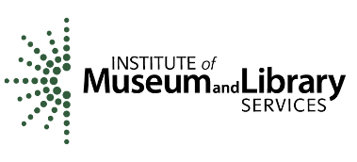
Funding for Idaho Summer Library Programs support is provided in part by the
Idaho Commission for Libraries, May 2021

