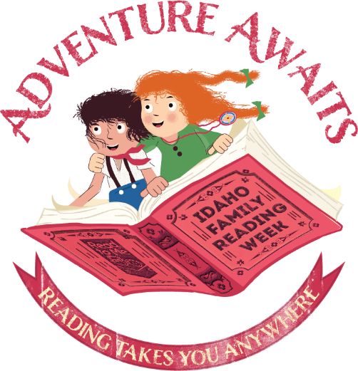

“Adventure Awaits”

Idaho Family Reading Week 2019

  - All Ages Storytime

Skill: Reading Together

Plan | Comments
Opening Song:  Zoom, Zoom, Zoom | This song will blast you off into storytime with fun lyrics and cool dance moves. Check out the Jbrary blog for different renditions.
Letter of the Day: A, a | A is for Adventure and Anywhere
Introduce theme:  Adventure Awaits: Reading Takes You Anywhere! | This year’s Idaho Family Reading Week theme is all about adventure. Today, we’ll read books and do activities that will take us to different places and give us a sense of adventure!
Book 1:  “Cece Loves Science and Adventure” written by Kimberly Darting and Shelli R. Johannes, and illustrated by Vashti Harrison | Join Cece and the Adventure Girls as they earn their camping badges using Science, Technology, Engineering, and Math. How would you have solved some of the problems that Cece encounters in the book?
Song:  Going on a Bear Hunt | This is a fun song to sing together that also has a lot of great movement. Check out this video if you need a refresher on the tune and lyrics.
Book 2:  “Journey” written and illustrated by Aaron Becker | Using a red marker, a young girl draws a door on her bedroom wall and through it enters another world where she experiences many adventures, including being captured by an evil emperor. This wordless book invites everyone in the family to tell the story and talk about what’s happening.
Movement Song:  Alabama Mississippi by Jim Gill | This song has it all – geography and shaking! Check out this video of Jim Gill singing it live.
Book 3:  “Peggy: A Brave Chicken on a Big Adventure” written and illustrated by Anna Walker | Peggy the hen is contented with her quiet existence and daily routine. When a powerful gust of wind sweeps her up and deposits her in the midst of a busy city, she explores her new surroundings, makes new friends, and cleverly figures out how to get home—with a newly kindled appetite for adventure. Evocative full-color paintings follow Peggy’s journey, offering comical details that reward repeated viewing. This reassuring tale and its unruffled heroine invites discussions of exploration, safety, and resourcefulness.
Closing Song:  Thanks for Coming | (Tune: Oh My Darling Clementine)  Thanks for sitting, thanks for listening,  Thanks for coming here today!  Now that storytime is over  Hope you have a lovely day!
Closing Comment: | Today, the whole family went on an adventure using books! Reading together is fun and something your whole family can do together.
Extension Activity:  Family Design Challenge | The characters in our books encountered lots of challenges. As a family, design an invention to help one of the characters overcome their challenge. BONUS: create a model of your invention using recycled materials.
Library Notes:

