

**Around the World Trivia**

(Ages 6-9)

1. People from which country eat the most macaroni & cheese?
   1. Canada
   2. United States
   3. Italy
   4. 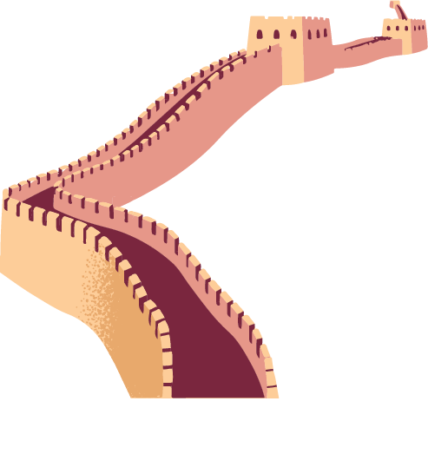Germany
2. Where was surfing invented?
   1. New Zealand
   2. Hawaii
   3. California
   4. Tahiti
3. Who was the first person to walk on the moon?
   1. Buzz Aldrin
   2. Apollo
   3. Neil Armstrong
   4. Sally Ride
4. What is the largest mammal on the planet?
   1. Elephant
   2. Blue Whale
   3. Nile Crocodile
   4. Koala

**Did you know?**

The Alnwick Castle, located in northern England, was used to film many famous scenes in the Harry Potter movies – it’s where Harry learned to fly a broomstick! More than 800,000 people visit it each year. Learn more: **“**[**https://tinyurl.com/see-the-castle**](https://tinyurl.com/see-the-castle)**”**

(more on back)

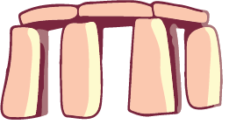If I were to be anywhere in the world right now it would be ____________________________________ because ____________________________________________________________________________.

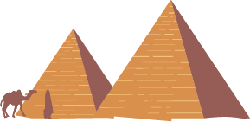

Here is a drawing of me there:

