

**Around the World Trivia**

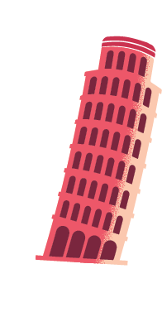(Ages 9-12)

1. Which country invented fireworks, the magnetic compass, nail polish, gunpowder, kites and chopsticks?
   1. China
   2. North Korea
   3. Sri Lanka
   4. India
2. Which forest produces 1/5 of the world’s oxygen?
   1. 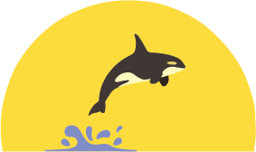Sequoia National Forest in California
   2. Black Forest in Germany
   3. Daintree Rainforest in Australia
   4. Amazon Rainforest in South America
3. Which country has the largest reef system in the world –

it’s so big it can even be seen from outer space? _____________________.

1. 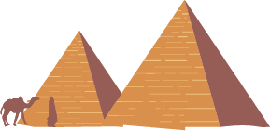Lots of people visit this country to see the giant pyramids. The oldest and largest pyramid was built around 2600 BC. _______________________.

**Did you know?**

Los Angeles' full name is "El Pueblo de Nuestra Señora la Reina de los Angeles de Porciúncula”?

There stands a castle in the Czech Republic that to this day has a moat filled with [bears](https://www.kickassfacts.com/30-interesting-bear-facts/). It’s called the “Bear Moat” and it was first filled with bears in 1707.

Learn more: **“**[**https://atlasobscura.com/places**](https://atlasobscura.com/places)**”** (search for “cesky castle”)

(more on back)

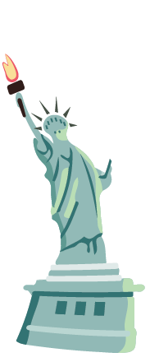If I were to be anywhere in the world right now it would be ______________________________

because ________________________________________________________________________.

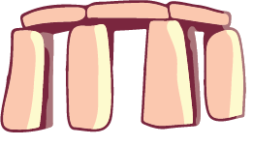

Here is a drawing of me there: