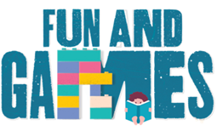
Idaho Family Reading Week 2020
- At the Library Game & Activity Ideas -

If you are able to offer in-person or in-library activities for Family Reading Week this fall, here are a few ideas to get your creative juices flowing OR adapt any of the other game and activity ideas provided for this program to work in the library:

- Jeopardy: Interested in an interactive digital Jeopardy game to play with your families? We have everything you need to create a Jeopardy game via PowerPoint! Customize it to whatever bookish theme you like! For more information, email Mandi at the Coeur d’Alene Library for more information: mharris@cdalibrary.org
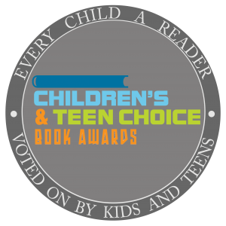
- Readers’ Choice Award Program: Want to give young patrons a chance to make their voices heard? Check out this guest post at Jbrary by Anne Pott, a librarian at the Herrick District Library in Michigan: https://jbrary.com/guest-post-readers-choice-award-program/.
- Children’s and Teens Choice Book Awards by Every Child a Reader: Not up for creating your own readers’ choice award program? Host an event where your younger patrons can browse the nominated titles, discuss their favorite books and then vote from the list of finalists. Promotional videos, voting tools and more resources can be found here: https://everychildareader.net/choice/. Voting ends on the last day of Idaho Family Reading Week - Nov 15th. How coincidental!
- Book Character Silhouette Scavenger Hunt: Some of our favorite characters have gotten lost in the library. Can you help? Check out this character-inspired library scavenger hunt by Jbrary and friends: https://jbrary.com/character-silhouette-scavenger-hunt/
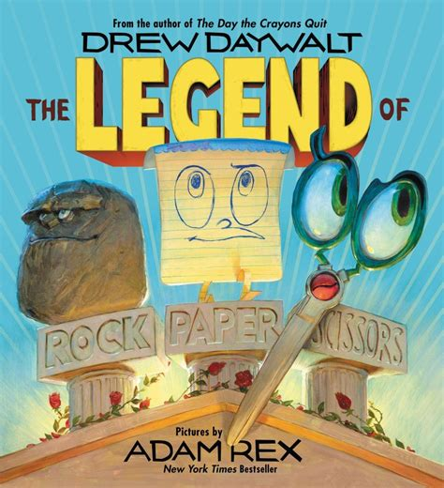
- Kahoot: Create your own literary Kahoot trivia game. There are loads of options here to create games by genre, age-group, characters, etc. Sign up is free and the app is also available in Spanish: https://kahoot.com/
- Rock, Paper, Scissors: Consider reading or showing this You Tube reading of the book “The Legend of Rock Paper Scissors” by author Drew Daywalt. Then have the kids/families get up and battle each other. Once they’re out of the round, kids keep cheering the winners on until the final battle. If you’ve got book savvy kids, you could come up with trios of characters and establish who-beats-who like Harry Potter, Percy Jackson and Artemis Fowl (complete with actions of course!)
- Close-Up Photo Hunt: Take zoomed in photos of things found in your library or children’s area and then let the kids loose to try to identify them as they rove the library. A great way to introduce new vocabulary, ensure kids know about all the sections of your library, or practice their reading skills and team work.
- Book Charades: Select a particular book and create a card deck of “charades” to act out and have your audience or teams guess. A great way for peers to share their enthusiasm for their favorite book or character.
- Scattergories: Create your own scattergories game with book/character themes and help families play it – or families could create their own.
- Write a Choose Your Own Adventure Story: Group writing activity - http://www.readwritethink.org/files/resources/lesson_images/lesson128/Graphic_organizer.pdf

