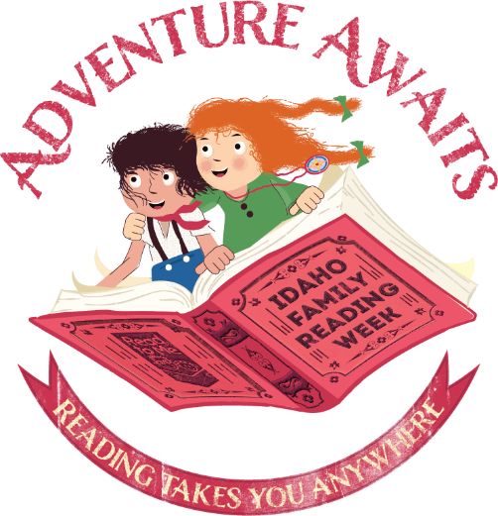

“Adventure Awaits”

Idaho Family Reading Week 2019

  - Babies & Toddlers Storytime

Skill: Reading Together

Plan | Comments
Opening Song:  Zoom, Zoom, Zoom | This song will blast you off into storytime with fun lyrics and cool dance moves. Check out the Jbrary blog for different renditions.
Letter of the Day: A, a | A is for Adventure and Anywhere
Introduce theme:  Adventure Awaits: Reading Takes You Anywhere! | This year’s Idaho Family Reading Week theme is all about adventure. Today, we’ll read books and do activities that will take us to different places and give us a sense of adventure!
Book 1:  “Bear Came Along” written by Richard T. Morris, illustrated by Leuyen Pham | Bear meets new friends as he has a wild adventure on the river.
Song:  Going on a Bear Hunt | This is a fun song to sing together that also has a lot of great movement. Check out this video if you need a refresher on the tune and lyrics.
Book 2:  “I am the Biggest Thing in the Ocean” written and illustrated by Kevin Sherry | What kinds of animals live in the ocean? Which ones are your favorite? If you lived in the ocean, what animal would you be? Asking open ended questions can help kids try new vocabulary and develop narrative skills.
Flannel Story:  Five Big Whales | This whale-themed flannel board from Storytime Katie is a fun way to practice counting to five and connects nicely with the previous book.
Book 3:  “Going Places” written and illustrated by Todd Parr | Todd Parr’s books are great for the whole family to read together. This one will take you on an adventure with planes, trains, shopping carts and rocket ships.
Closing Song:  Thanks for Coming | (Tune: Oh My Darling Clementine)  Thanks for sitting, thanks for listening,  Thanks for coming here today!  Now that storytime is over  Hope you have a lovely day!
Closing Comment:  Reading together is important | Today we went on an adventure together with our books. We followed Bear down the river and went on a bear hunt, we explored ocean animals and practiced counting to five, and we talked about all the places we can go in different vehicles. Reading together is a fun way to spark your child’s imagination and introduce her to new concepts and ideas.
Extension Activity:  Handprint Ocean Animals | You can make a fish or an octopus with paint, paper, tiny hands, and googly eyes, like these ones from apumpkinandprincess.com:  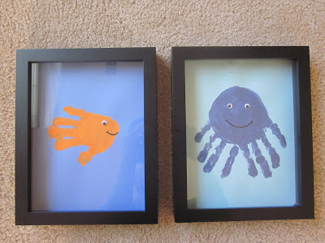
Library Notes:

