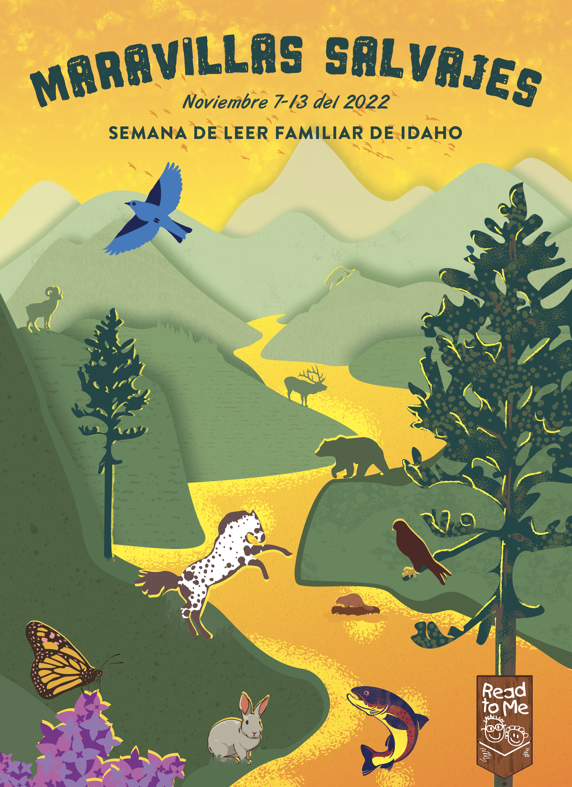
Library Name or Any Title
Description goes here, Description goes here, Description goes here, Description goes here, Description goes here,
Description goes here, Description goes here, Description goes here, Description goes here,
Description goes here, Description goes here, Description goes here,

