Idaho Family Reading Week 2021
“Believe and Achieve” Recommended Reading List

Preschool - Early Elementary Ages:
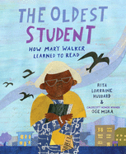
The Oldest Student: How Mary Walker Learned to Read, by Rita Lorraine Hubbard and illustrated by Oge Mora (Ages 4-8) – a featured title for Idaho Family Reading Week 2021
“In 1848, Mary Walker was born into slavery. At age 15, she was freed, and by age 20, she was married and had her first child. By age 68, she had worked numerous jobs, including cooking, cleaning, babysitting, and selling sandwiches to raise money for her church. At 114, she was the last remaining member of her family. And at 116, she learned to read. From Rita Lorraine Hubbard and rising star Oge More comes the inspirational story of Mary Walker, a woman whose long life spanned from the Civil War to the Civil Rights Movement, and who--with perseverance and dedication--proved that you're never too old to learn.”

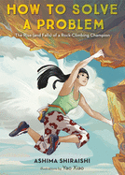
How to Solve a Problem: The Rise (and Falls) of a Rock-Climbing Champion, by Ashima Shiraishi (Ages 4-8) – a featured title for Idaho Family Reading Week 2021
“Describes solving a complex problem in terms of rock climbing, which may include false starts, breaking the challenge into smaller parts, and always being thoughtful and persistent.”

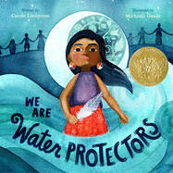
We Are Water Protectors, written by Carole Lindstrom and illustrated by Michaela Goade (Ages 4-8) – a featured title for Idaho Family Reading Week 2021
“Water is the first medicine. It affects and connects us all... When a black snake threatens to destroy the Earth and poison her people's water, one young water protector takes a stand to defend Earth's most sacred resource. Inspired by the many indigenous-led movements across North America, this bold and lyrical picture book issues an urgent rallying cry to safeguard the Earth's water from harm and corruption.”
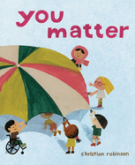
You Matter, by Christian Robinson (Ages 4-8) – a featured title for Idaho Family Reading Week 2021

“Illustrations and easy-to-read text remind the reader that no matter what happens or how one feels, he or she matters.”

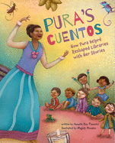
Pura’s Cuentos: How Pura Belpré Reshaped Libraries with Her Stories, by Annette Bay Pimentel and illustrated by Magaly Morales (Ages 4-8) - a featured title for Idaho Family Reading Week 2021
“Lyrically written, with lively illustrations, Pura's Cuentos captures the exuberant spirit and passion of Pura Belpré celebrated storyteller, author, folklorist, and the first Latina librarian in New York City. A pioneer of bilingual storytimes, she welcomed countless new families to the library, formed cultural bridges in her community, and broke the rules by telling stories that weren't printed in books--at least, not yet.

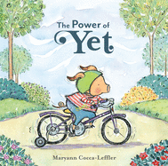
The Power of Yet, by Maryann Coca-Leffler (Ages 3-5)
“A little pig, frustrated by the limitations of his young age and small size, is encouraged to keep trying, growing, and learning until he meets his goals.”

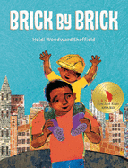
Brick by Brick, by Heidi Woodward Sheffield (Ages 3-7)
An Ezra Jack Keats Honor Book
“Papi is a bricklayer, and he works hard every day to help build the city, brick by brick. His son, Luis, works hard too--in school, book by book. Papi climbs scaffolds, makes mortar, and shovels sand. Luis climbs on the playground and molds clay into tiny bricks to make buildings, just like Papi. Together, they dream big about their future as they work to make those dreams come true.”

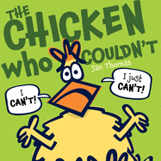
The Chicken Who Couldn’t, by Jan Thomas (Ages 3-5)
“Chicken has fallen out of Farmer's truck! He can't possibly get himself all the way home...can he?"

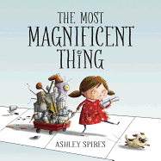
The Most Magnificent Thing, by Ashley Spires (Ages 3-7)
“A little girl and her canine assistant set out to make the most magnificent thing. But after much hard work, the end result is not what the girl had in mind. Frustrated, she quits. Her assistant suggests a long walk, and as they walk, it slowly becomes clear what the girl needs to do to succeed. A charming story that will give kids the most magnificent thing: perspective!”

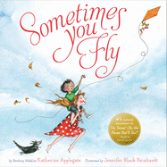
Sometimes You Fly, by Katherine Applegate (Ages 4-6)
“A sweet book of encouragement, filled with humor and insight into the effort behind any meaningful accomplishment in life.”

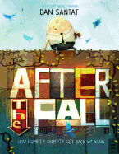
After the Fall (How Humpty Dumpty Got Back Up Again), by Dan Santat (ages 4-8)
“From a Caldecott Medalist and "New York Times"-bestselling author-illustrator comes the inspiring epilogue to a beloved nursery rhyme. Now terrified of heights after his fall, Humpty Dumpty can longer do many of the things he loves most. Will he summon the courage to face his fear?”

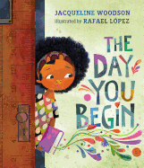
The Day You Begin, by Jacquiline Woodson (Ages 4-8)
"A beautiful and inclusive story that encourages children to find the beauty in their own lives and share it with the world. . . . Each child feels very alone until they begin to share their stories and discover that it is nearly always possible to find someone a little like you.”

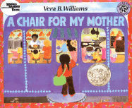
A Chair for My Mother, by Vera Williams (Ages 4-9):
After a fire destroys their home and possessions, Rosa, her mother, and her grandmother save their money to buy a big comfortable chair that they can all enjoy. Suffused with warmth and tenderness, "A Chair for My Mother" celebrates family love and determination.

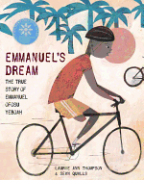
Emmanuel’s Dream: The True Story of Emmanuel Ofosu Yeboah, by Laurie Ann Thomson (Ages 4-8):
Born in Ghana, West Africa, with one deformed leg, he was dismissed by most people--but not by his mother, who taught him to reach for his dreams. As a boy, Emmanuel hopped to school more than two miles each way, learned to play soccer, left home at age thirteen to provide for his family, and, eventually, became a cyclist. He rode an astonishing four hundred miles across Ghana in 2001, spreading his powerful message: disability is not inability. Today, Emmanuel continues to work on behalf of the disabled.

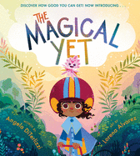
The Magical Yet, by Angela Diterlizzi (Ages 4-8)
“Each of us, from the day we're born, is accompanied by a special companion--the Yet. Can't tie your shoes? Yet! Can't ride a bike? Yet! Can't play the bassoon? Don't worry, Yet is there to help you out. The Magical Yet is the perfect tool for parents and educators to turn a negative into a positive when helping children cope with the inevitable difficult learning moments we all face. Whether a child or an adult, this encouraging and uplifting book reminds us that we all have things we haven't learned...yet!”

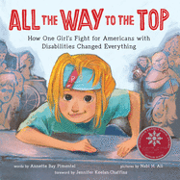
All the Way to the Top: How One Girls Fight for Americans with Disabilities Changed Everything, by Annette Bay Pimentel, illustrated by Nabi Ali (Ages 4-9),
Honor Book of Schneider Family Book Award - Educator's Guide by teacher Jenna Vandenberg
“Diagnosed with cerebral palsy at birth, Jennifer Keelan grew up battling-and overcoming-the limitations others set for her. From a lack of cutaway curbs and bus lifts to being denied enrollment at her neighborhood school, Jennifer was continually blocked from living the life she wanted. But after discovering the world of disability rights activism, she knew she had to use her voice to change things.”
*Idaho connection! The author, Annette Bay Pimentel, lives in Moscow, Idaho and loves doing school and library visits. Consider reaching out to get her involved in your Idaho Family Reading Week program.

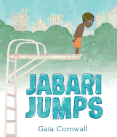
Jabari Jumps, by Gaia Cornwall (Ages 4-8)
“Even though he's successfully finished his swimming lessons, Jabari discovers that he's frightened at the thought of jumping off a diving board.”

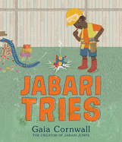
And…

Jabari Tries, by Gaia Cornwall (Ages 4-8)
"Jabari is inventing a machine that will fly all the way across the yard! But making it go from CRASH to WHOOSH will take grit, patience, and maybe even a little help from his sister."

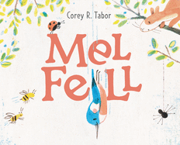
Mel Fell, by Corey Tabor (Ages 4-8)
"Young people, who find themselves on the precipice of new activities, routines, schools, and challenges so frequently, will savor this little kingfisher's success and perhaps feel they can right themselves the next time they fall into a downward spiral.... Encourages children to feel brave, to try, and to believe they can soar."

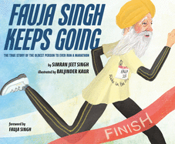
Fauja Singh Keeps Going: The True Story of the Oldest Person to Ever Run a Marathon (Ages 4-9)
“"The inspiring true story of Fauja Singh, who broke world records to become the first one hundred-year-old to run a marathon, shares valuable lessons on the source of his grit, determination to overcome obstacles, and commitment to positive representation of the Sikh community.”

Upper Elementary Grades:
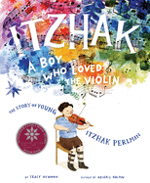
Itzhak: A Boy Who Loved the Violin, by Tracy Newman (Ages 5-9), Honor Book of Schneider Family Book Award
“Before becoming one of the greatest violinists of all time, Itzhak Perlman was simply a boy who loved music… this picture-book biography recounts Itzhak's childhood journey--from a boy with a dream to an internationally acclaimed violin virtuoso.”

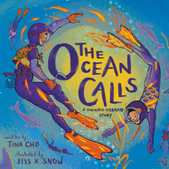
The Ocean Calls: A Haenyeo Mermaid Story, by Tina Cho (Ages 5-8)
"A picture book featuring a Korean girl and her haenyeo (free diving) grandmother about intergenerational bonds, finding courage in the face of fear, and connecting with our natural world."

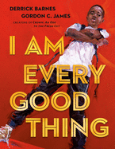
I Am Every Good Thing, by Derrick Barnes (Ages 5-9): Book Guide
“The confident Black narrator of this book is proud of everything that makes him who he is. He's got big plans, and no doubt he'll see them through--as he's creative, adventurous, smart, funny, and a good friend. Sometimes he falls, but he always gets back up. And other times he's afraid because he's so often misunderstood and called what he is not. So slow down and really look and listen when somebody tells you--and shows you--who they are. There are superheroes in our midst!”

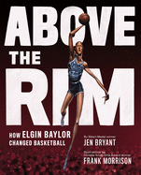
Above the Rim: How Elgin Baylor Changed Basketball, by Jen Bryant (Ages 5-9)
“Hall-of-famer Elgin Baylor was one of basketball's all-time-greatest players--an innovative athlete, team player, and quiet force for change. One of the first professional African-American players, he inspired others on and off the court.”
*Idaho connection! Elgin played basketball at College of Idaho during his career!

Ish, by Peter H Reynolds, (Ages 5-9)
“A gentle tale of a creative free spirit who learns that thinking "ish-ly" is far more wonderful that "getting it right.”

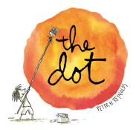
And…

The Dot, by Peter H Reynolds, (Ages 5-9)
“A simple, witty story that entices even the stubbornly uncreative to make a mark and follow it on a journey of surprise and self-discovery.”

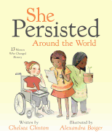

She Persisted Around the World: 13 Women Who Changed History, by Chelsea Clinton (Ages 5-8)
“"She Persisted" introduces readers to 13 incredible women who have shaped history all across the globe.”
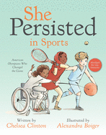
And…
She Persisted in Sports: American Olympians Who Changed the Game, by Chelsea Clinton (Ages 5-8)“In this book, Chelsea Clinton introduces readers to woman athletes who have excelled in their sports because of their passion, their skills and their persistence."

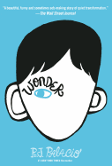
Wonder, by RJ Palacio (Ages 8-12)
“Ten-year-old Auggie Pullman, who was born with extreme facial abnormalities and was not expected to survive, goes from being home-schooled to entering fifth grade at a private middle school in Manhattan, which entails enduring the taunting and fear of his classmates as he struggles to be seen as just another student.”

Middle Grades:
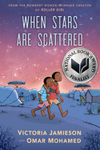
When Stars Are Scattered, by Omar Mohamed and Victoria Jamison (Ages 9-12), Finalist for National Book Award – Educator Guide & Additional Resources/Book Trailer
"Omar and his younger brother Hassan live in a refugee camp, and when an opportunity for Omar to get an education comes along, he must decide between going to school every day or caring for his nonverbal brother in this ... portrayal of family and daily life in a refugee camp."

Get a Grip, Vivy Cohen!, by Sarah Kapit (Ages 8-12)
“Vivy Cohen is determined. She's had enough of playing catch in the park. She's ready to pitch for a real baseball team. In this perfectly pitched novel-in-letters, autistic eleven-year-old Vivy Cohen won't let anything stop her from playing baseball--not when she has a major-league star as her pen pal.”

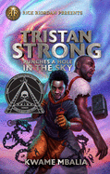
Tristan Strong Punches a Hole in the Sky, by Kwame Mbalia (Ages 8-12)
“Mbalia's epic debut centers African American characters and tradition, featuring a pantheon of legends and a plot worthy of such tricksters as Brer Rabbit and Anansi the Weave… It brims with heart, humor, and action, successfully crafting a beautifully unified secondary world that brings the power of stories to glorious life.”

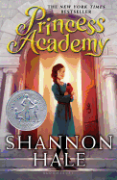
Princess Academy, by Shannon Hale (Ages 10-13)
“Miri lives on a mountain where, for generations, her ancestors have lived a simple life. Then word comes that the king's priests have divined her village the home of the future princess. In a year's time, the prince will choose his bride from among the village girls. The king's ministers set up an academy on the mountain, and every teenage girl must attend and learn how to become a princess. Soon Miri finds herself confronted with a harsh academy mistress, bitter competition among the girls, and her own conflicting desires. Winning the contest could give her everything she ever wanted--but it would mean leaving her home and family behind.”

The Impossible Rescue: The True Story of an Amazing Arctic Adventure, by Martin Sandler (Ages 12-15)
“In 1897, whaling in the Arctic waters off Alaska's coast was as dangerous as it was lucrative. And in that particular year, winter blasted in early, bringing storms and ice packs that caught eight American whale ships and three hundred sailors off guard. Their ships locked in ice, with no means of escape, the whalers had limited provisions on board, and little hope of surviving until warmer temperatures arrived many months later. Here is the incredible story of three men sent by President McKinley to rescue them.”
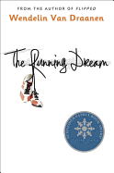

The Running Dream, by Wendelin Van Draanen (Ages 12+), Teen Winner of Schneider Family Book Award
“Jessica thinks her life is over when she loses a leg in a car accident. She's not comforted by the news that she'll be able to walk with the help of a prosthetic leg. As she struggles to cope with crutches and a first cyborg-like prosthetic, Jessica feels oddly both in the spotlight and invisible.”

