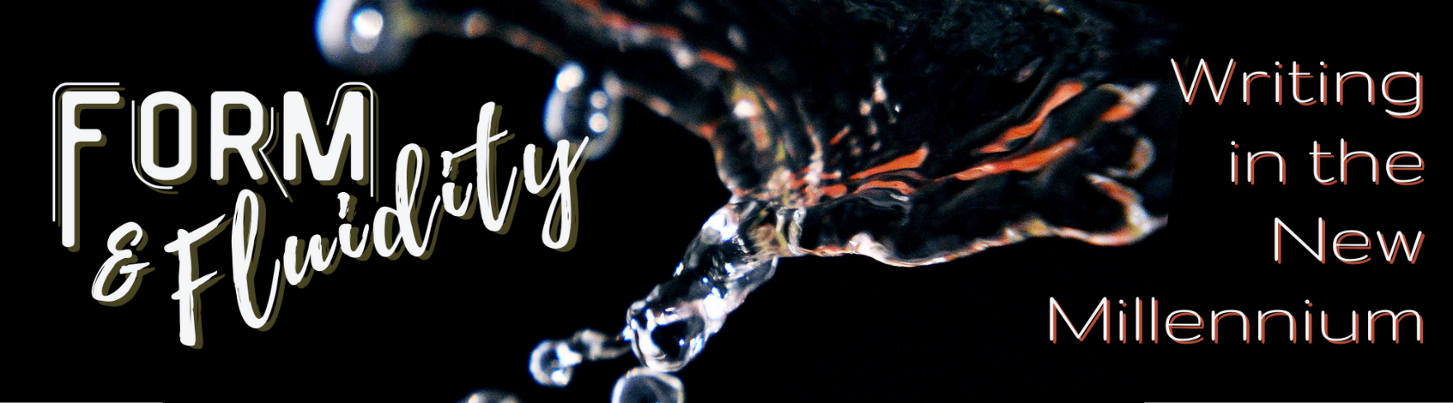
 | Program Information  MM/DD/YYYY, 00:00  Book Title #1  MM/DD/YYYY, 00:00  Book Title #2  MM/DD/YYYY, 00:00  Book Title #3 | Library Information  Librarywebsite.com  email@librarywebsite.com  (208) xxx-xxxx  12345 Library Street  Library Town, ID XXXXX
 | Program Information  MM/DD/YYYY, 00:00  Book Title #1  MM/DD/YYYY, 00:00  Book Title #2  MM/DD/YYYY, 00:00  Book Title #3 | Library Information  Librarywebsite.com  email@librarywebsite.com  (208) xxx-xxxx  12345 Library Street  Library Town, ID XXXXX
 | Program Information  MM/DD/YYYY, 00:00  Book Title #1  MM/DD/YYYY, 00:00  Book Title #2  MM/DD/YYYY, 00:00  Book Title #3 | Library Information  Librarywebsite.com  email@librarywebsite.com  (208) xxx-xxxx  12345 Library Street  Library Town, ID XXXXX
 | Program Information  MM/DD/YYYY, 00:00  Book Title #1  MM/DD/YYYY, 00:00  Book Title #2  MM/DD/YYYY, 00:00  Book Title #3 | Library Information  Librarywebsite.com  email@librarywebsite.com  (208) xxx-xxxx  12345 Library Street  Library Town, ID XXXXX

