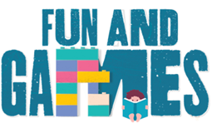
Idaho Family Reading Week 2020
- Grab ‘N Go Bags/Curbside Delivery Game & Activity Ideas -

- A comprehensive list of “grab n’ go/take n’ make/teen try it” bag ideas collected by Idaho Commission for Libraries’ staff: “Idaho Libraries Kits Roundup” (Aug 2020)
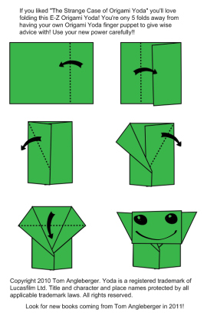
A few examples of themed Grab ‘N Go or Take & Make Bags:
2) STEM Take and Make bags:
      - “Grab Lab” ideas from Madison Public Library (ID):
    - https://madisonlib.org/grab-lab-hickory-dickory-water-clock/
    - https://madisonlib.org/grab-lab-ariels-periscope/

3) Arts & Crafts –
      - Take & Make Craft Kit ideas from Campbell County Public Library (KY): https://www.cc-pl.org/make-take-bags - taking to laundromats for pick-up
      - Marigold Grow Kits and Nature Journal Curbside Kits from Latah County Library, ID: https://www.youtube.com/watch?v=CdCbT7-9Lbo
      - Origami Folding kit: Provide paper and instructions to fold some of Tom Angleberger’s origami creations like Origami Yoda, Darth Paper, Princess Labelmaker and more! https://www.youtube.com/playlist?list=PLA50E07CCCD9669C4
- and don’t forget about Baby Yoda!

4) Teens –
      - https://madisonlib.org/teen-summer-crafts-origami-cranes/
      - https://madisonlib.org/teen-summer-crafts-harry-potter-bookmarks/
      - https://madisonlib.org/teen-summer-crafts-dragon-eggs/
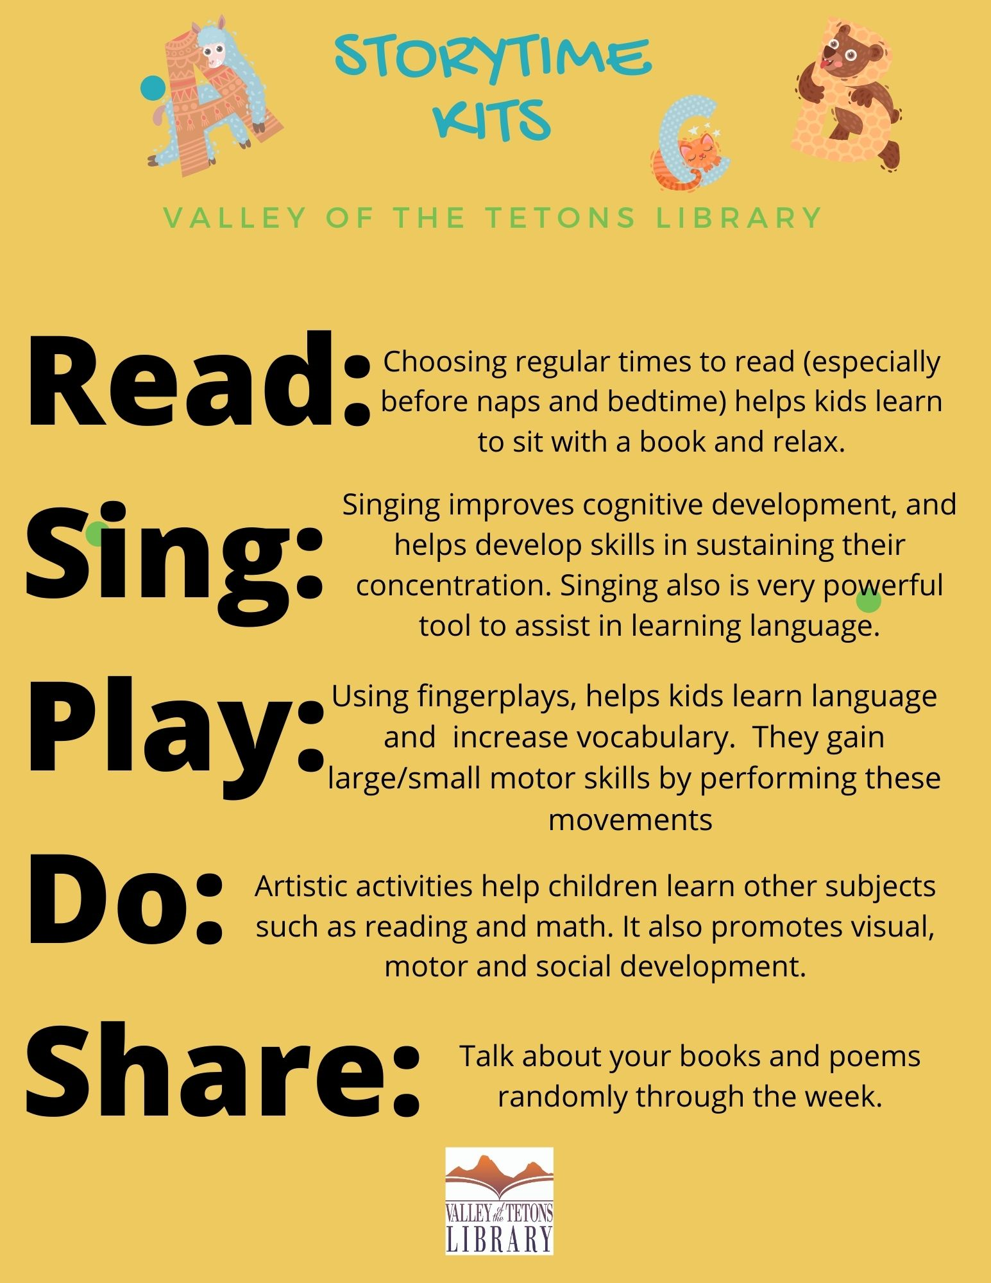
      - https://madisonlib.org/teen-summer-crafts-wizard-wand-pens/

5) Early Literacy/Kindergarten Readiness Bag –
- Create bags filled with reading challenge materials – reading logs, recommended reading lists, bookmarks, etc. See Children’s Book Week (also Nov 2020) for free, downloadable reading challenges, bookmarks, and other activity sheets: https://everychildareader.net/cbw/cbw-resources/

- Kindergarten Readiness Bag Ideas: Worksheets to practice lettering, and using scissors, laminated Bingo cards to reuse, add a dry erase marker. Share fingerplays booklet, sing-along songs, and add some finger puppets to keep and use. Send ideas for parents and caregivers for literacy ideas and motivation to keep going. Of course add some books.
- 5 Early Literacy Kit ideas from Colorado State Library - view them here: https://www.coloradovirtuallibrary.org/learning/literacy/5-early-learning-library-take-and-make-kits/

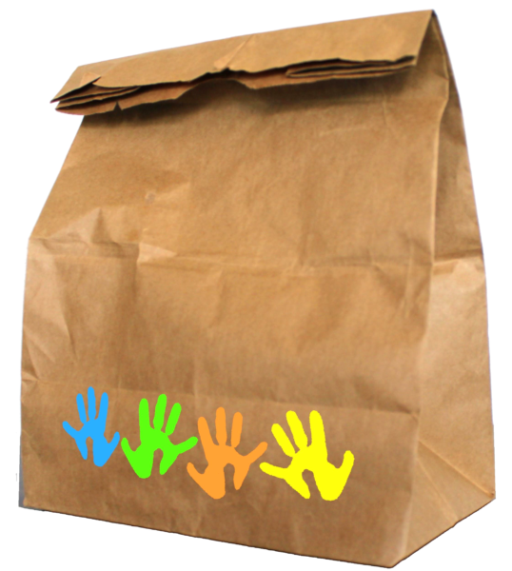
6) Mystery Bag – Create a bag filled with random craft materials (stickers, paper, crayons, glue stick, puff balls, googly eyes,etc.) and let the kids go wild!

7) Library videos that are paired with grab bags/curbside material handouts:
Salmon Public Library’s Grab N Go video’s
- Family Kit #1: Puppets “My Story” - https://www.youtube.com/watch?v=KWAiR8P_D9s&vq=hd1080
- Independent Reader #1: Chalk Art - https://www.youtube.com/watch?v=MXqF_dwjjPU&vq=hd1080%C2%A0%20

