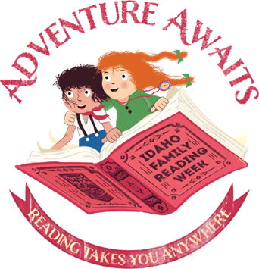

“Adventure Awaits”

Idaho Family Reading Week 2019

  - Preschool Storytime

Skill: Reading Together

Plan | Comments
Opening Song:  Zoom, Zoom, Zoom | This song will blast you off into storytime with fun lyrics and cool dance moves. Check out the Jbrary blog for different renditions.
Letter of the Day: A, a | A is for Adventure and Anywhere
Introduce theme:  Adventure Awaits: Reading Takes You Anywhere! | This year’s Idaho Family Reading Week theme is all about adventure. Today, we’ll read books and do activities that will take us to different places and give us a sense of adventure!
Book 1:  “Mapping Sam” written and illustrated by Joyce Hesselberth | Explore different types of maps as we follow Sam the cat on his nighttime adventures.
Song:  The Ants Go Marching | This is a classic song about some ants that march to adventure. You can easily add movement and almost everyone knows the tune. Check out this video if you need a refresher on the song.
Book 2:  “Scaredy Squirrely Goes Camping” written and illustrated by Melanie Watt | Scaredy Squirrel must face the great outdoors in this fun book about camping. The next time your family goes on an adventure, make checklists like Scaredy Squirrel to help kids develop print awareness and practice writing.
Flannel Story:  We’re Going on a Bear Hunt | Going on a Bear Hunt is a great song for movement and also makes a fun flannel board. Here is a version from Storytime Katie.
Book 3:  “We Are the Dinosaurs” written by Laurie Berkner; illustrated by Ben Clanton | Follow the dinosaurs on a fund marching adventure. You can also pair this book with Berkner’s song of the same name. Reading and singing together are great ways for families to make reading fun.
Closing Song:  Thanks for Coming | (Tune: Oh My Darling Clementine)  Thanks for sitting, thanks for listening,  Thanks for coming here today!  Now that storytime is over  Hope you have a lovely day!
Closing Comment: | Today we read books about different types of adventures. We learned about maps and used checklists, both of which help kids develop print awareness. We also incorporated marching and dancing into our adventures, which helps with the development of gross motor skills and executive function.
Extension Activity:  Draw your own map | Hand out paper and crayons to the kids and ask them to draw their own map: it could be the map of their house, their neighborhood, or a pirate’s map to find buried treasure!
Library Notes:

