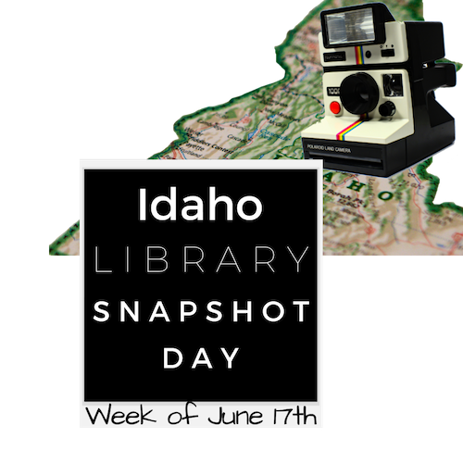
Today is our

Idaho Library

Snapshot Day!

We will be taking
photographs and/or video footage
of people using the library today.

If you do NOT wish to be photographed, please tell the person taking the photo/video, and they will not photograph/videotape you.

We would appreciate you taking a minute or two to fill out a comment form, to let us know how you use the library.

And/or email comments to: name@emailaddress.

Thank you for helping us capture a typical day
in our Idaho library.

